Malaysian
Bat Party Pack

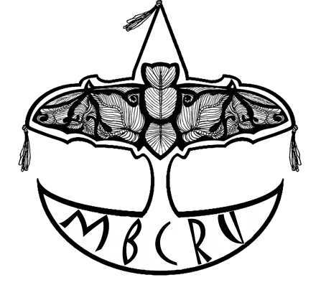

Welcome to the Malaysian Bat Party Pack!

Malaysia is a fantastic treasure-house of bats, the jewel in the crown of Southeast Asian bat diversity with 125 bat species, 12 of which are found nowhere else in the world. 40% of all Malaysian mammals are bats and in rainforest habitats they make up more than half the mammal species. Malaysian bats include some of the smallest and biggest bats in the world. Many species play a critical role in pollination, seed dispersal and pest control. Sadly, 34 species are officially at some risk of extinction and many more are threatened by forest clearance and changes in land use.

In Malaysia very little is known about bats. Typically what is misunderstood is disliked. This is the case for bats; they are often viewed as pests or carriers of diseases and many people still believe some of the old myths that surround them. The Bat Party Pack aims to raise the profile of Malaysian bats by providing a basic understanding of their biology, ecology and importance to us.

The Bat Party Pack is a comprehensive guide for teachers, parents and educators to hold a fun but educational bat party for children aged 7-12. It includes basic information about Malaysian bats, detailed descriptions of activities, how to make the relevant materials and tips on how to organise the event. The pack can be used in it’s entirety to hold the complete party, or the activities can be individually integrated into existing outreach programmes.

If you would like more information about bats or Malaysian bat education activities, visit the MBCRU website or contact us at:

Prof. Dr. Zubaid Akbar
Malaysian Bat Conservation Research Unit
School of Environmental & Natural Resource Sciences
Faculty of Science & Technology
Universiti Kebangsaan Malaysia
43600 UKM Bangi, Selangor, MALAYSIA
Email: zubaid@pkrisc.cc.ukm.my

Dr. Tigga Kingston
Malaysian Bat Conservation Research Unit
Department of Geography
Boston University
Boston MA 02215, USA
Email: tigga@bu.edu

Contents

The Bat Party Outline………………………………….….….….….….….….……...3
How to Organise the Bat Party….….….….….….….….……………………….…5
Arrival and Registration……………...…………….….….….…………….….….….7
Bat Attitudes………………………………………………………...………………..10
Introducing Bats………………...…………………………..............…………….…11
Compare Yourself to a Bat…………….…………………….……..……………...20
The Puppet Show………………………..…..….………………………..................60
Breaktime: Bat Fruit Salad…………………..………………..………..….………..84
Game: Bat-Moth…………….….….………….………………...……..….….……..86
Game: Where’s My Baby?................................................................................88
Quiz………………………………………..…..………………….…………………….90
Grand Finale………………………………………………………………................94
Other Templates
Game: Memory Bat……………………………………….…………………95
Bat Mobile………………………………………………….………………...100
Comic…………………………………………………………………………108

The Bat Party Outline

Objectives: To raise awareness of the general biology, morphology, ecology and utility of Malaysian bats.
To create an appreciation of Malaysian bats as interesting, charismatic and important animals.

Ages: Children ages 7-12

Duration: Around 2 to 2 ½ hours

The contents of the Malaysian Bat Conservation Research Unit Bat Party Pack has been organized in a logical progression of activities and topics. However, this does not mean you have to start at the beginning and carry out each activity to the end of the book. Each activity is self-contained and contains objectives, materials, instructions and steps on how to conduct the activity. Therefore, you can opt to focus on just a couple of activities or conduct the whole bat party from the beginning until the end of the Bat Party Pack.

Introduction: Basic information regarding the topic is mentioned to give an idea of what the activity is about at the beginning of each activity.
Objectives: The main purpose of the activity being carried out and the goals for each activity.
Materials: Items that should be prepared beforehand and be ready when you want to carry out the activity.
Instructions: Directions on how to prepare the materials needed for the party.
Steps: Directions on how to carry out the actual activity.
Bat Information
for Educators: Basic concepts an educator should know before carrying out the activity and background for developing a dialogue.
Discussion Points
for Educators: For discussion with the children after the activity. Can be used to introduce more specific points or to place the activity in a broader evolutionary context.

Activity | Objective | Material | Time
Arrival  and  Registration | Divide children into groups  Distribute name tags | List of children’s names  Group name tags | 20 mins
Bat Attitudes | Find out knowledge and perceptions of bats | Bat Attitude Survey questions | 10 mins
Introducing Bats | Introduce children to the diversity of bats and their basic biology | Bat costume  Bat mask  Slide show | 20 mins
Compare Yourself to a Bat | Understanding of bat anatomy and the similarities between bats and people.  Empathise with bats | Bat jigsaws  A2 size paper  Stockings  Rice  Comparison table  Blue tac or tape  Tape measure  Kitchen scales Bathroom scales  Pencils | 1 hour
The Puppet Show | Introduce the importance of bats | Back drop or stage, puppets, script, sound system, microphones | 30 mins
Breaktime:  Bat Fruit Salad | Reinforce the understanding of bats as pollinators and seed dispersers | Fruit pollinated or dispersed by bats  Large bowl | 20 mins
Game:  Bat-Moth | Demonstrate echolocation | Blindfolds | 20 mins
Game:  Where’s My Baby? | Demonstrate how mothers find their babies in large maternity roosts | Blindfolds  Smells  Cotton wool balls | 20 mins
Quiz | Demonstrate and reinforce what has been learnt | Quiz question cards | 20 mins
Grand Finale | Find out bat knowledge and concept changes  Give prizes | Bat costume  Bat Attitude Survey questions  Comic and mobile | 10 mins
How to Organise the Bat Party

Here are same flexible guidelines that we have found useful when organising the Bat Party.

- Find out the location and facilities available at the party site. Confirm the date beforehand.
- Find out how many children are attending. (We recommend 1 facilitator for every 10 children. There should be a minimum of 10 children and the maximum should not exceed 30 children).
- Plan and prepare the activities involved.
- Ensure all materials are prepared and available at the party. Work on those materials which are most difficult and time consuming first.
- Send invitations with time allowed for notice and confirmation of attendance.
- Get a list of the names of the children from the registration list. This will allow you to allocate them into groups and prepare nametags.
- It is advisable to prepare a checklist to ensure all materials are organized and everyone knows their role in the party.

Tips
  - Have an organiser who allocates tasks and roles and manages time.
  - If possible, have one individual responsible for each activity.
If there are many children, older children, mothers or teachers
could be invited to help facilitate the activities and supervise
the children.
  - Be prepared to be flexible. Have some spare materials in case
extra children appear.
  - Make sure everyone (parents/teacher/helpers) knows what they
are doing throughout the party.
  - Prepare a schedule of times, activities, tasks and names.

Invitation Templates
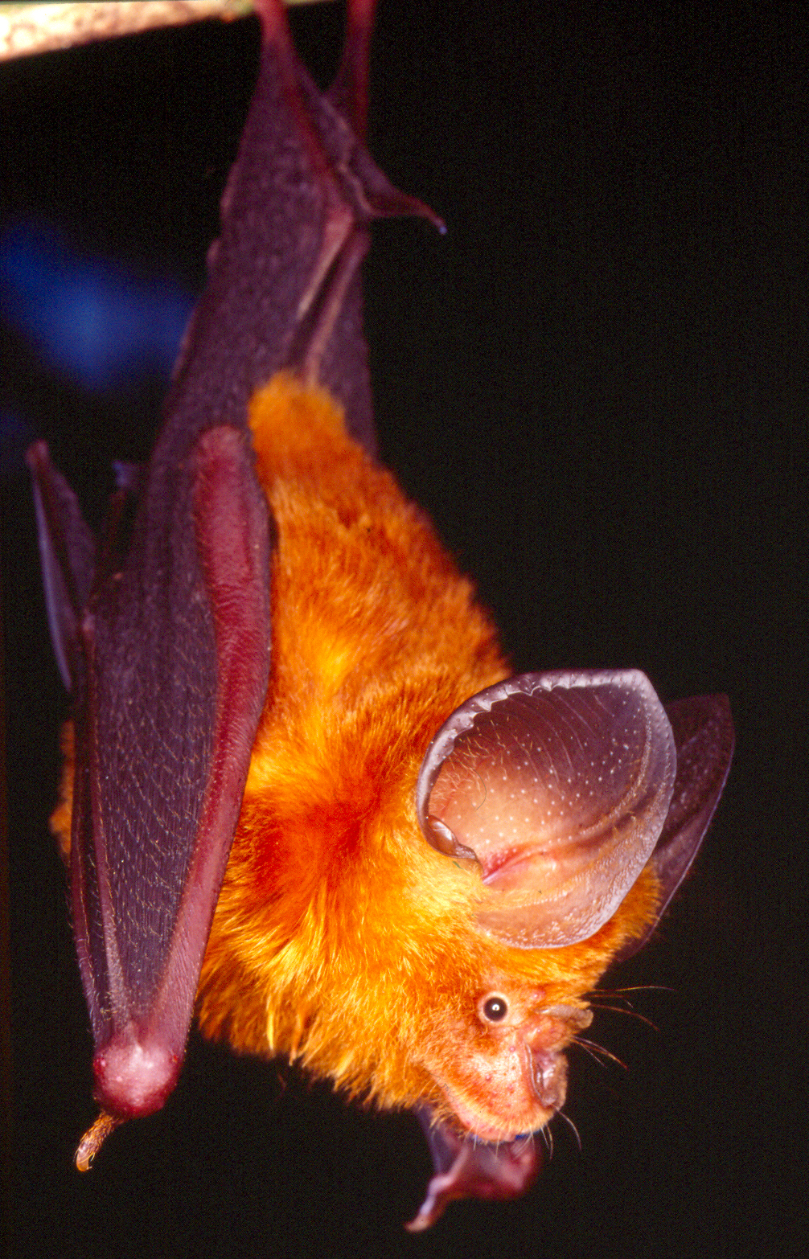

MBCRU invites
__________________________________________________________________
to a BAT PARTY!
Date: 14 May 2004
Time: 3 pm – 6 pm
Venue: Bukit Rengit
Dengan sukacitanya MBCRU menjemput
__________________________________________________________________
ke PARTI KELAWAR!
Tarikh: 14 Mei 2004
Masa: 3pm-6pm
Tempat: Bukit Rengit
Arrival and Registration

Objectives:
To gather children into groups and distribute name tags.

Materials:
List of children’s names
Pens
Name tags
Scissors
Safety pins
Cellophane tape

Instructions:
- Use the templates in Fig 1 as a guideline for the name tag templates. Trace around the name tag templates on coloured cards and cut out accordingly.
- Attach a safety pin to the back of each name tag using cellophane tape.

Steps:
- Set aside an area with a desk, list of names, name tags and a pen.
- As parents and children arrive, mark them off the list and give them their name tag.
- Gather children into groups of 4-5.

Tips
- Keep early birds entertained! Have something prepared for them to do or an area to go to while they are waiting for others to arrive. (e.g. slideshow/pictures/plasticine to play with/games like Memory Bat etc.)

Fig 1 Name Tag Templates
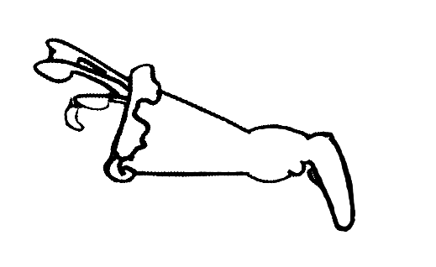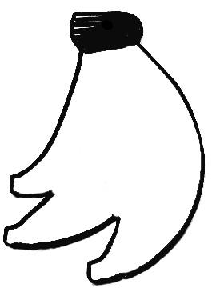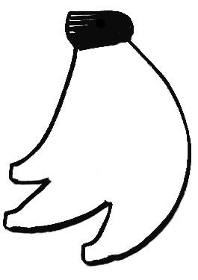
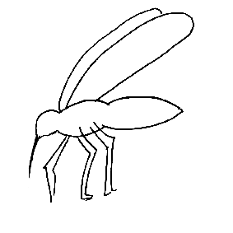
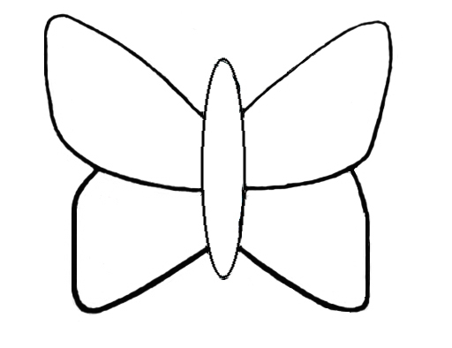
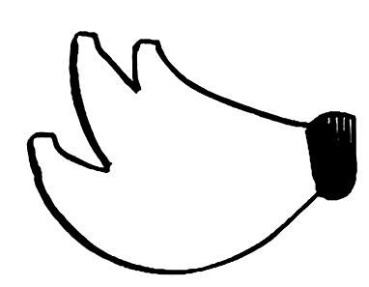
Bat Attitudes

It is interesting and very useful to find out what the children have learned from the bat party. To do this you need to find out what they already know, and this can be determined with an informal oral survey at the start of the party. These questions will be asked again at the end to determine what the children have learned. This activity can be incorporated into the beginning of the introduction.

Objectives:
Find out existing bat knowledge and perceptions.
To determine awareness levels before and after the party.

Materials:
Bat Attitude Survey questions
Someone to record how many children have raised their hands for each question

Steps:
- Welcome the children and have them seated in a semi-circle.
- Explain the instructions before conducting the Bat Attitude Survey.
- Encourage children to raise their hands if they want to answer the questions.
- Explain that they can only answer once for each question.
- Ask the prepared questions.
- Someone writes down the number of children who have answered each question.
Bat Attitude Survey Questions
Questions may be asked and recorded on a sheet of paper such as:
    - Do you like bats?
    - Are bats clean?
    - Are you afraid of them?
    - Are bats useful animals?
    - What are bats most like – birds, mice, shrews?
    - How many different kind of bats do you think there are in Malaysia? – 5, 50 or more than 100?

Introducing Bats

Meet Gema and her friend Fruity!
A fun way to introduce children to bats is by dressing up as a bat. This way, they can see what a bat generally looks like. It also provides the opportunity to ask what they already know about bats and to give them basic information about bats such as what a bat is, where they live and what they eat.

Bat Information for Educators
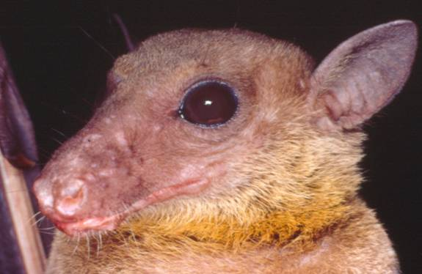
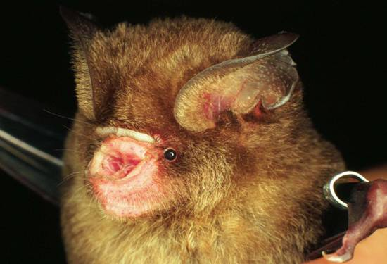
There are about 125 different species of bats in Malaysia and more than 1111 in the world. Bats are the only mammals that can truly fly. Their scientific name is ‘Chiroptera’ meaning ‘hand-wing’. The wings are made of two thin but tough and flexible layers of skin and tendons stretched over the bones of the hand. These amazing creatures have fur-covered bodies and wings largely without fur. The World’s bats are divided into two distinct groups: the larger flying foxes or megabats (Megachiroptera) and the smaller microbats (Microchiroptera).

Eonycteris spelaea Hipposideros cervinus
(Megachiroptera) (Microchiroptera)

There are about 178 species of megabats worldwide, with 20 species occurring in Malaysia. They are only found in the Old World tropics (Asia, Africa and Australia). They feed exclusively on fruit, flowers, nectar and pollen. Megabats have large eyes and simple ears, and simple muzzles that often give them a dog-like appearance, and the larger species are referred to as ‘flying foxes’. They do not echolocate but use vision to find their way about and vision and smell to select ripe fruits or flowers.

The microbats are found on every continent except Antarctica, and there are over 1000 species, with 98 known for Malaysia. In the Old World they are predominantly insectivorous, with a few species taking small vertebrates like mice and lizards. However, in South and Central America where there are no megabats, it is the microbats that visit plants for fruit, nectar and pollen. Microbats are usually smaller than megabats, and because they rely on echolocation to find their way about, and to detect and locate their insect prey, they tend to have small eyes and elaborate, large ears. Some species echolocate through their mouths, but in others the sound is sent out through the nostrils and is focussed by a complicated noseleaf.

Objectives:
Introduce bats, what they are, what they look like, what they eat and where they live.

Materials:
2 bat costumes - 1 megabat and 1 microbat, prepared in advance. (If you cannot make two costumes, just use one costume and switch between the megabat and microbat masks).

Instructions:
Activity Preparation for one bat costume
2m x 1m rubber or thick plastic sheet, black
Large sheets of cardboard
1m length of fur fabric (brown, black, grey, etc)
20 chopsticks, or wooden satay sticks
4m thick black tape, 1 inch wide (strapping is ideal), black
Strong glue (UHU multi purpose or rubber cement) – 1 large tube
Scissors
Pens

- Cut out the wings and body templates from cardboard. Draw the wings to be 2m across from tip to tip, using the picture from Fig 2.1 as a guide. The body template is peanut-shaped, with a hole in the centre for your head. Use the measurements in Fig 2.2 as a guide.
- When you have your templates drawn out on the card, cut them out, put the body to one side, and lay the wings template on top of the rubber sheet and draw around it. Cut out using a pair of strong, sharp scissors.
- Mark out where the bat’s fingers and arms are. First mark from the last wing tip straight up to the top. This will be the thumb and little finger, and should measure around 60cm from the third wing tip. Then make a mark 5cm from the edge of the thumb. This is where all the other fingers and the elbow will join. Do this on both sides. See Fig 2.3.
- Mark the position of the bat’s elbow. Measure 45cm up from the outside of the foot and mark it. This is where the shoulder of the bat starts. Draw a diagonal line 20cm in length from this point to make the elbow. Then join the elbow to the fingers with a 30cm line. See Fig 2.4.
- When all the lines for the wing bones are drawn out, arrange the chopsticks and lay them out where they should be stuck. Some lines will need two sticks, others only one (there might be some small gaps between the sticks, but it doesn’t matter. Just try and make it equal).
- Glue each stick carefully in the positions you have marked. Leave to dry.
- When the sticks are in place and the glue is dry, start sticking the tape over them. Do this one at a time. Lay the tape or strapping material over the stick and cut the right length to cover the stick completely. Put plenty of glue on the tape and stick down (it will take a few minutes to stick properly, so press down firmly). Repeat this for all the sticks, leaving the longest one, for the little finger and thumb, until last, to cover up all the ends. Remember to cut this material 5cm longer at the top for the bat’s claw. See Fig 2.5.
- While the glue is drying you can get on with the body. Get the card template you prepared earlier and draw around it on the back of the fur fabric, then cut it out.
- After the glue on the wings is thoroughly dry, turn the wings over and position the body in the middle, lining up the neck hole with the wing edge. When you are happy with the position, glue in place and press down firmly. See Fig 2.6.
- Cut two bat feet out of brown cardboard and glue in place on the back of the fur fabric.
- Cut out one of the bat masks from this pack and laminate it. Then you can thread elastic around the back of the mask. Now your bat costume is ready you can start flapping around like a REAL bat! See Fig 2.7.

Steps:
- Have the children sit in a semi circle.
- Put the microbat mask/costume on and introduce Gema the bat. Ask the children to describe her.
- Put the megabat mask/costume on and introduce Fruity. Ask the children to compare the two bats faces.
- Ask the children why they think they have these differences and tell them why, giving them more information about bats.

Suggested Dialogue

‘’Who has seen a bat before? What is a bat? Can anyone tell me? Is it a bird? A flying mouse? You must have seen one flying around a lamp post at night. Who likes bats? Raise your hands if you like bats! If you don’t it’s probably because you don’t know what they are. A bat is a mammal, just like you and me, warm-blooded animals that have fur and give birth to live babies who feed on their mother’s milk. Mother bats usually have only one baby a year, which they look after and teach to fly and find food. Bats are the only mammals that can truly fly. They have been named ‘Chiroptera’ meaning ‘hand-wing’. The wings are made of two thin but tough and flexible layers of skin and tendons stretched over the bones of the hand. The world’s bats are divided into two distinct groups: the larger flying foxes or megabats (Megachiroptera) and the insect-eating bats or microbats (Microchiroptera).

Who can tell me what a bat looks like? (A person comes out wearing the bat costume and Rhinolophus trifoliatus mask.) This is Gema our friendly bat! See her broad wings, they allow her to hunt for insects by manoeuvring her way through the dense vegetation of the forest. Look at her nose and ears. What does it look like? Why do you think she looks like that? She is a trefoil horseshoe bat and her scientific name is Rhinolophus trifoliatus, (have the kids repeat the name) a microbat. What does micro mean? Microbats are small and in Malaysia usually eat insects. Her noseleaf helps her echolocate. Do you know what that means? This is when she shouts and listens to her echo to find out where things are. She does this to help her find her way about the forest and find food. Her home is called a roost and you can find her under large leaves. Can you guess Gema’s weight? Gema weighs only 15g.

This is Fruity (A person comes out wearing the bat costume and Pteropus vampyrus mask.) Fruity is also known as a large flying fox. His scientific name is Pteropus vampyrus (have the kids repeat the name). Look at his face, how is it different to Gema’s? Why do you think this is? Fruity is a Megabat, he needs his big eyes and nose find fruit to eat. In the wild he is very sociable – he likes to live in a large group with over 500 friends! His roost is called a ‘camp’ – and the whole group will hang from the branches of one or two trees, turning them black with bats! They are usually found near the coasts, roosting in mangrove areas or remote forests that are hard for people to reach. And how heavy do you think Fruity is? Fruity weighs about 1.2kg. He’s the biggest bat in the world! His wings are over 1.5m across – I bet that’s taller than most of you. Unfortunately, his family is often hunted, for food, traditional medicine or even just for sport, so Fruity and his friends are a much rarer sight now than they would have been when your grandparents were your age.

Gema and Fruity are just two of the bats we have here in Malaysia. There are many different types of bats, some of them are small whereas others are big! Can you guess how many different types of bats there are in Malaysia? There are about 125 different species – that’s a tenth of all the bats in the world. How many kinds of bats do you think there are in the world? More than 1111! They make up over a fifth of all the mammals.

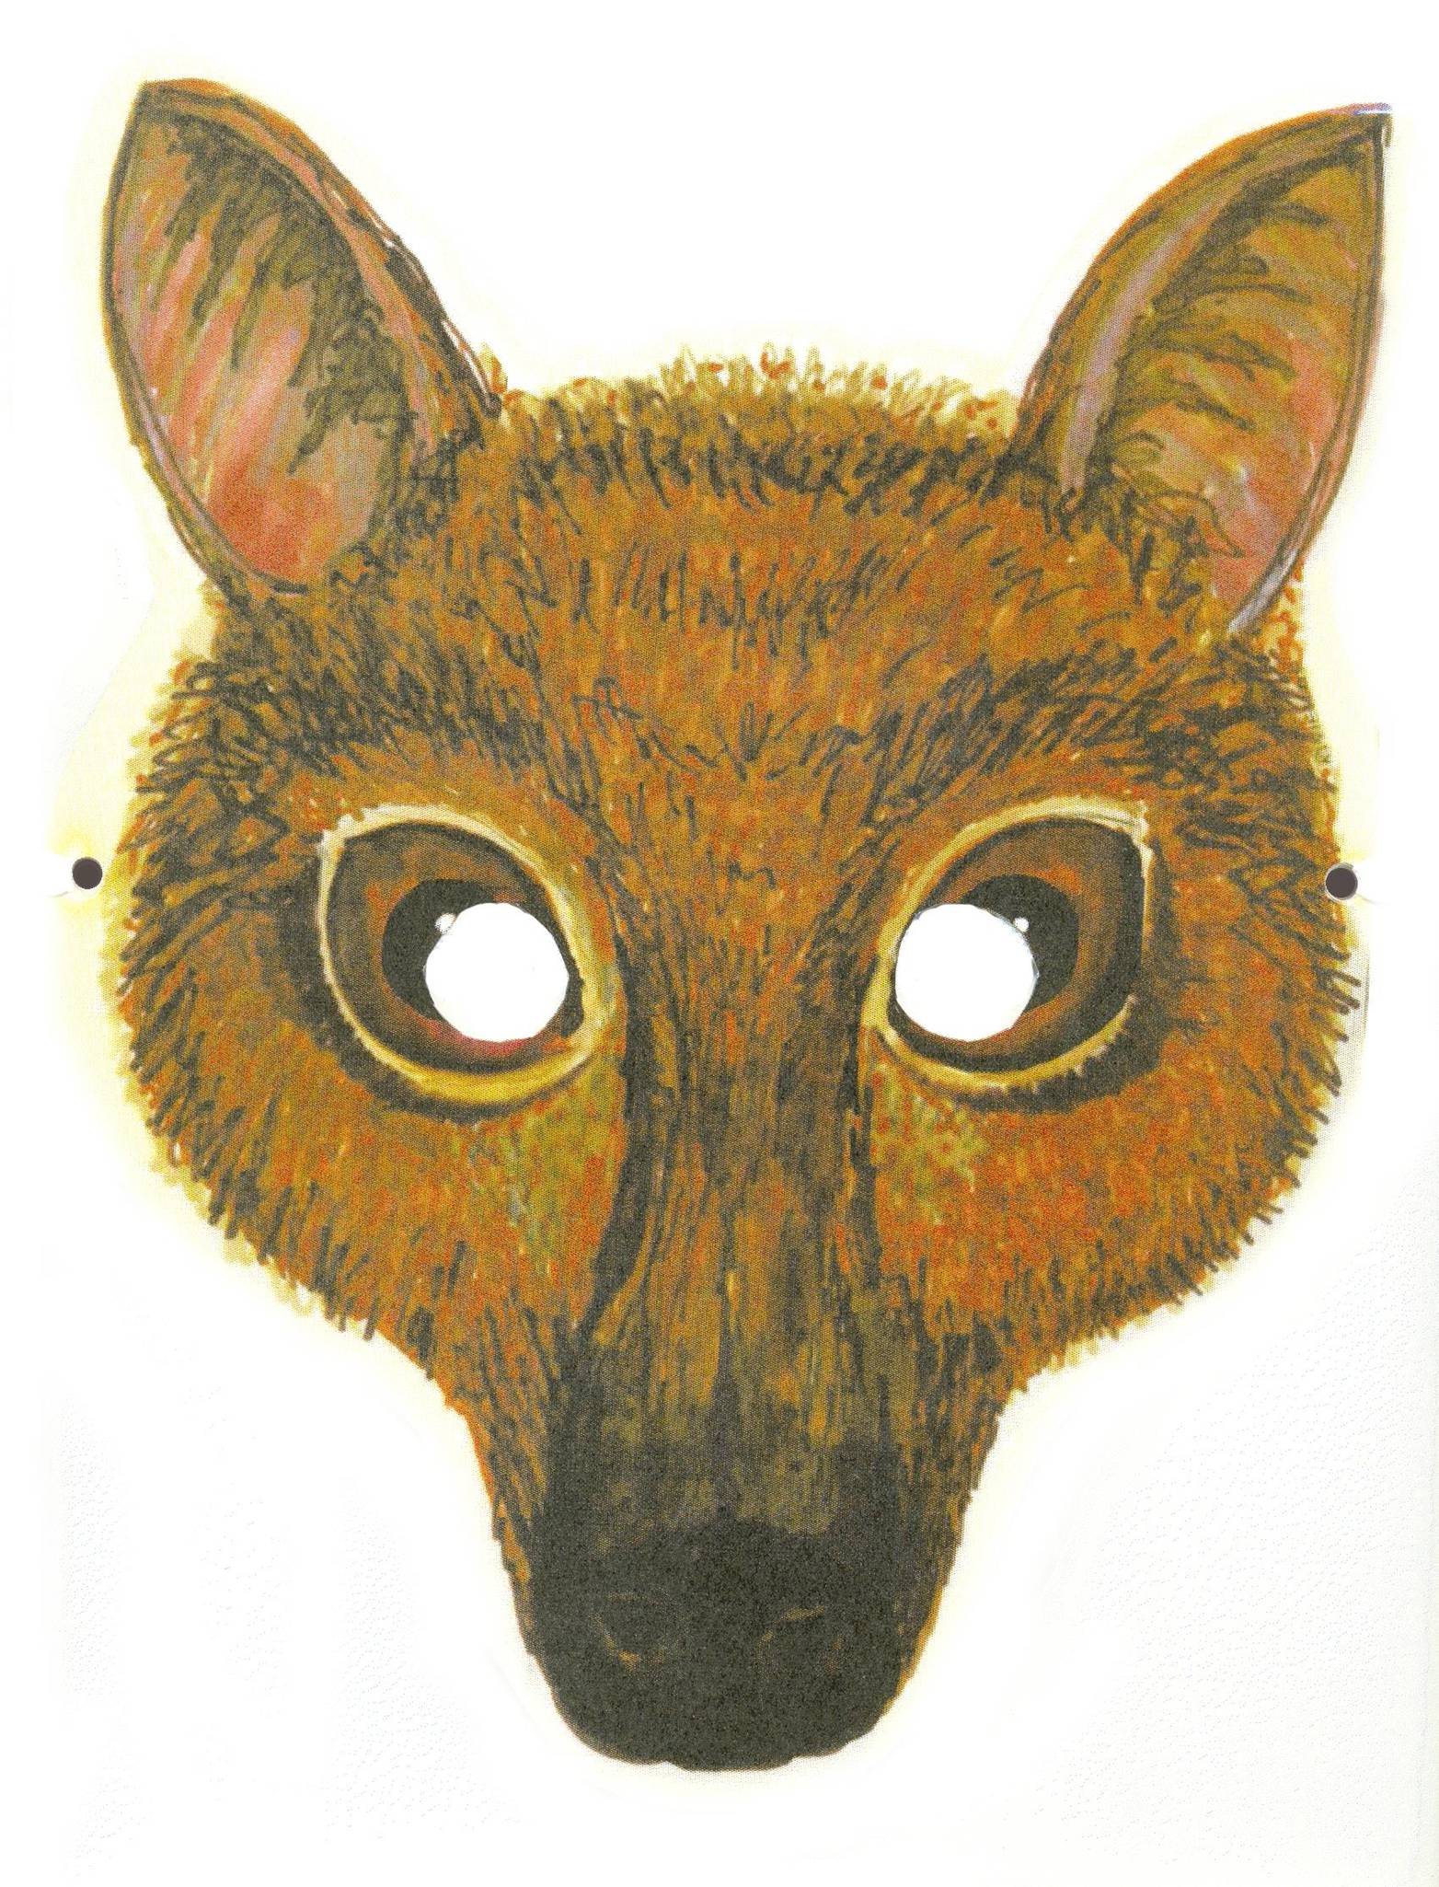
Megabat Mask Template
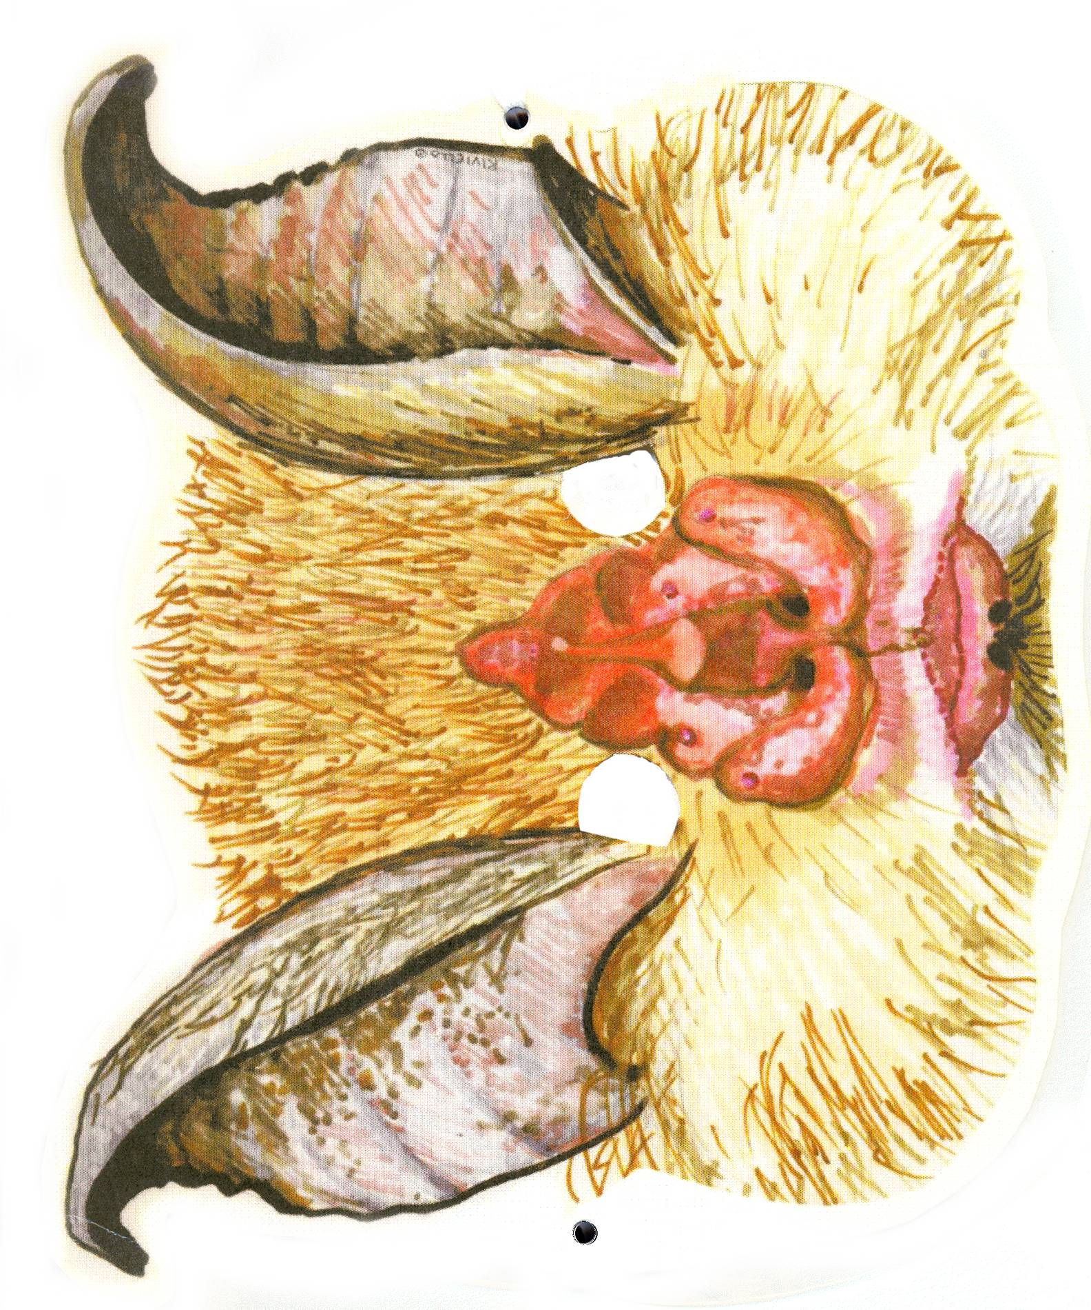
Microbat Mask Template
Bat Costume Templates

Fig 2.1

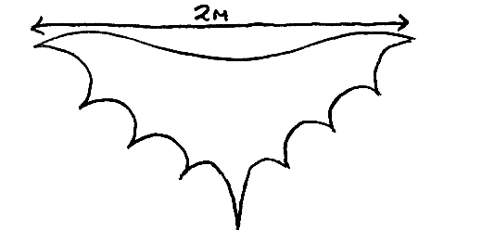

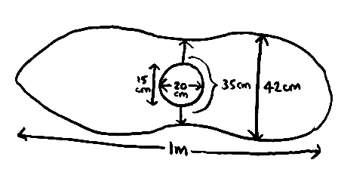
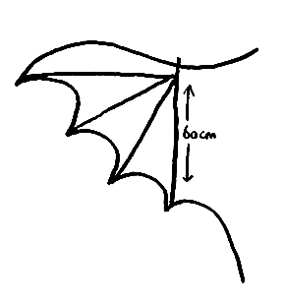
Fig 2.2
Fig 2.3
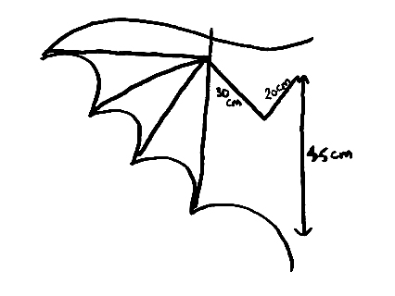
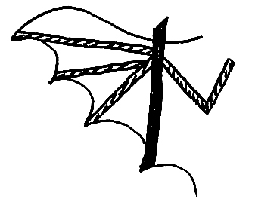
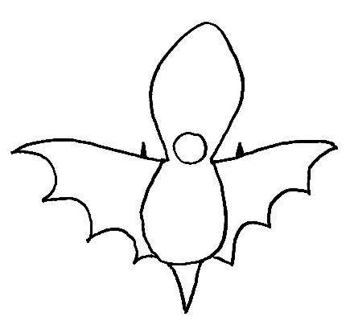
Fig 2.4
Fig 2.5
Fig 2.6
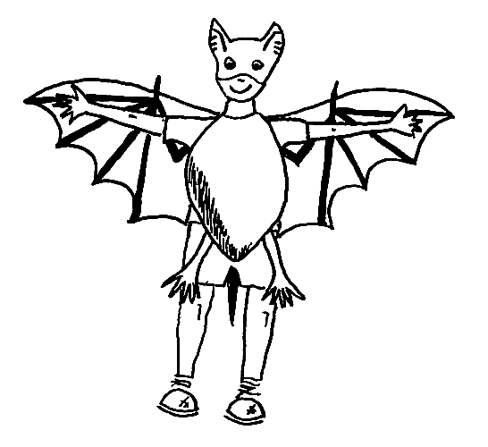
Fig 2.7
Compare Yourself to a Bat

When you understand bats, you can easily begin to relate to and empathise with them. In this activity children compare themselves to bats. This will help the children gain a better understanding of bats so they relate to some aspects of their appearance and life-style.

This activity comprises 3 sections: the Jigsaw Puzzle, the Comparison Table and a presentation from each group of their bats and the Wing Measurement Guess. The Jigsaw Puzzle will help children appreciate the uniqueness of different bats. The Comparison Table helps the children find out about a specific species and how they are similar to that bat. It also helps them appreciate the diversity of bats as each group will have a very different species to work with, but all the bats featured can be found in a single forest of Malaysia. This section of the activity is further explained by filling stockings with suitable material to demonstrate the actual weight of bats. The Wing Measurement Guess will motivate the children to understand the physical anatomy of bats and empathise with them.

Objectives:
To enable children to appreciate the uniqueness of bats.
To enable children to realise the diversity of bat species.
To enable children to gain a better understanding of the physical anatomy of bats.
To enable children to relate to and empathise with bats.

Bat Information for Educators
Bats come in all shapes and sizes. The world’s smallest bat (the bumblebee bat from Thailand) weighs only two grammes. The largest bat, the flying fox, weighs 1.2kg. The majority of bats weigh less than 50g.

Bats and people are similar in many ways. As mammals, bats give birth to live young, nurse babies with milk and have hair. Baby bats, called pups, rely on their mothers to care for them, just like human babies.

Bats are the only mammals that truly fly. A bat’s wing is really a modified hand and they actually fly with their fingers. The wings are made of two thin but tough and flexible layers of skin and tendons stretched over the bones of the hand. The wing bones are actually greatly elongated fingers. Like humans, bats also have five fingers.

Materials:
One for each group:

Part A
Jigsaw (prepared in advance)

Part B
Comparison table (prepared in advance)
Blue tac or alternative to display comparison table
Pencils
White board marker
Stockings, cut up and knotted to make small bags for weighing rice.
Rice (beans or small pebbles may be used as an alternative)
Kitchen and bathroom scales

Part C
Large piece of paper (A2 size, at least)
Measuring tape

Instructions:
Activity preparation

Part A
- Print out photos of bats on A4 paper and stick onto stiff cardboard.
- Cut photos to create the jigsaw.

Part B
- Copy the Comparison Table onto a white board or large piece of paper (1 per group).
- Have one facilitator to supervise each group.
- Print out a bat information sheet for each facilitator (there is one for each species, ensure photos and sheets correspond).
- The facilitator can print out a separate completed table as an example.

Part C
- Prepare a large piece of paper or white board (A2 size).
- The facilitator should have information regarding the ratio of a bat’s wing in relation to a child’s hand. The ratio of a bat’s forearm to its 3rd finger is 1:1.4.

Steps:
Part A
- Have the children sit in their groups and explain what they are going to do.
- Give each group a bat jigsaw to complete.
- When it is complete have the children discuss their completed jigsaws. What does the bat’s face look like? Where are its ears, eyes and nose? Is this what they thought a bat actually looks like?

Part B
- Distribute the comparison table, bat information cards and wing traces (the bat information card and wing traces correspond to the jigsaw), kitchen scales, bathroom scales, rice, stocking and white board marker. If there are only a few groups for this activity, select bats with extreme contrasts in terms of weight or how they live to demonstrate bat diversity.
- Ask each group to complete their jigsaws. Then join up the wing traces if needed (explain this is the actual size of the bat).
- Choose a child to be compared to a bat, another to write in the table and others to take readings of measurements and weights (Note: Stockings + rice = weight of bat).
- The children use the Bat Information Cards to complete the table. Starting with the formal name, they fill in the table from ‘bat’ to ‘me’ then proceed to the common name. Use the kitchen scales, rice and stocking bags to find out what the weight of the bat is really like.
- When the table is complete the children discuss the similarities and differences of the bat and child.
- Following this, each group presents their Comparison Table results.

Part C
- Pin a large piece of paper (A2 size) onto the wall.
- Get one volunteer to stand against the paper with their arm outstretched.
- Ask each group how much bigger the volunteer’s fingers have to be in relation to the forearm in order to have a wing like a bats. Have a child from each group come up and mark on the paper where they think the third finger would finish.
- When all the groups have had a guess, measure the volunteer’s forearm. The ratio of a bat’s forearm to its 3rd finger is 1:1.4. Multiply the length of the child’s forearm by 1.4. This is the length the finger would be if the child were a bat (e.g. if the volunteer’s forearm is 20 cm, their 3rd finger would need to be 28 cm). Measure this out on the paper from the volunteer’s wrist).
- The group that guesses most correctly wins a point for the team.
Suggested Dialogue

Did you enjoy fixing the bat puzzle? Look at their faces! What did your group’s bat look like? Some of the bats have long faces, like a dog. Others have short faces. Look at the shape of their ears! Do you notice that different bats also have very different looking ears? See their eyes! Some have large eyes, others have tiny eyes. Take a look at their noses! Why do they all look so different?

The shape of a bat’s face is largely determined by the shape of the jaws. The jaws of bats reflect their food habits. The most striking variation is in length. Most insectivorous species have moderately-sized jaws. Short, thick jaws are more common in species that specialize on hard-bodied insects such as beetles or fruits that are difficult to penetrate. Nectar-feeding bats frequently have greatly elongated jaws so that they can fit their muzzles and tongues into flowers to reach the nectar at the base of the flower. Fruit-eating species have jaws that are considerably shortened.

Look at the bat’s ears! Although most mammals use hearing as one of their main senses, bats have developed their hearing systems to an extraordinary extent. Their reliance on echolocation has caused striking evolution in the structure of both their inner and outer ears. In the visually oriented Megachiroptera, the external ears are of moderate size, rounded or slightly pointed, and without additional complicated structures. Ear shape and size are quite diverse only in the echolocating Microchiroptera.

Most bats in the suborder Microchiroptera have small eyes because echolocation is their major system of orientation. This has led to the common misperception that bats are blind. The expression “blind as a bat” is inappropriate because all bats can see. Most species probably use vision to a certain degree, especially where there is sufficient light. megachiropterans are highly visually oriented. They have large eyes, which, combined with expressive faces, make them considerably more appealing. They use their excellent vision for both navigation and foraging.

Look at the noses on the insect-eating bats! Do you know why they look so unique? The feature that separates microchiropteran bats from most other mammals is echolocation, the superbly developed navigational system that allows them to picture the environment through sound. The bat shouts out high-frequency sounds, either through their mouth or through its nostrils and the complicated noseleaf is used to help focus the sound. Echoes bounce back from the bat’s prey item and the surrounding environment. That way, bats are able to navigate and locate their food even in almost complete darkness. None of the Megachiroptera use true echolocation, but a few species that live in caves click their tongues to find their way about in the darkness of the cave.

Jigsaw Puzzle Pictures
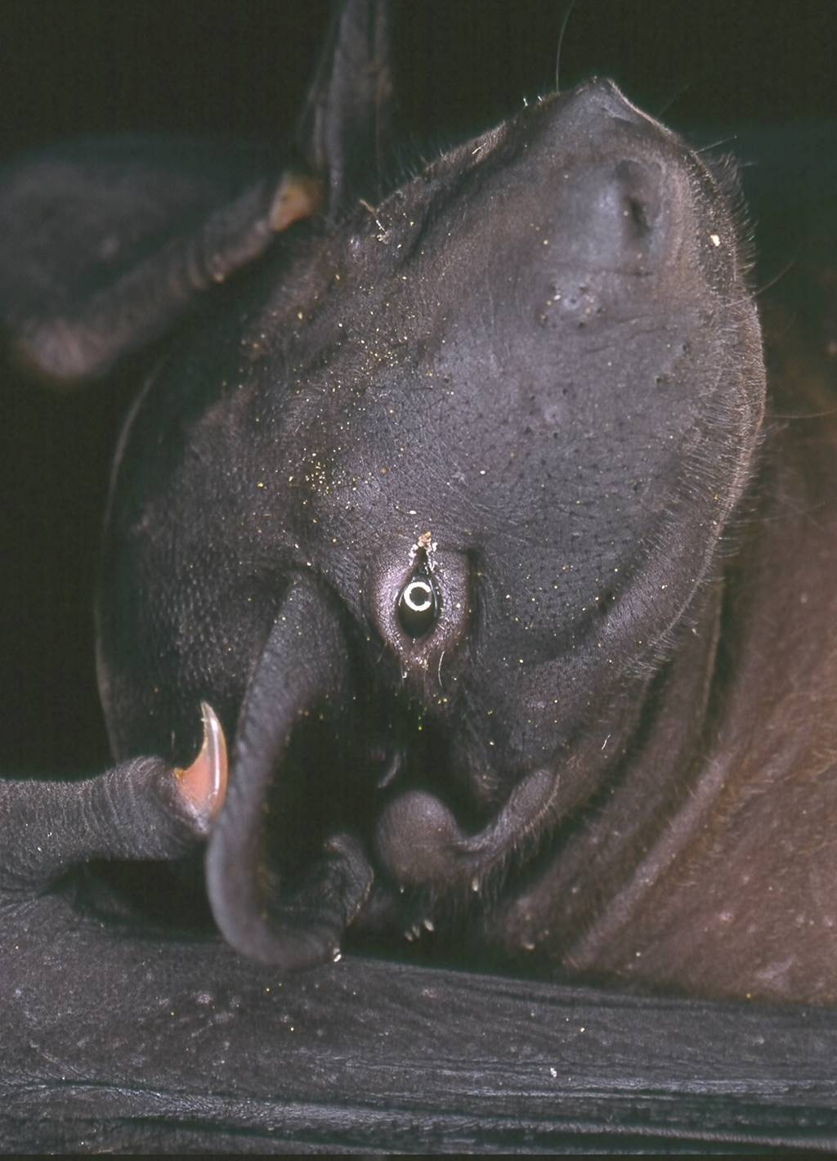
Cheiromeles torquatus
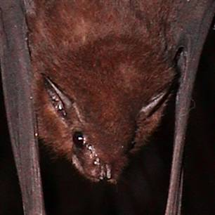

Emballonura monticola

Hipposideros bicolor

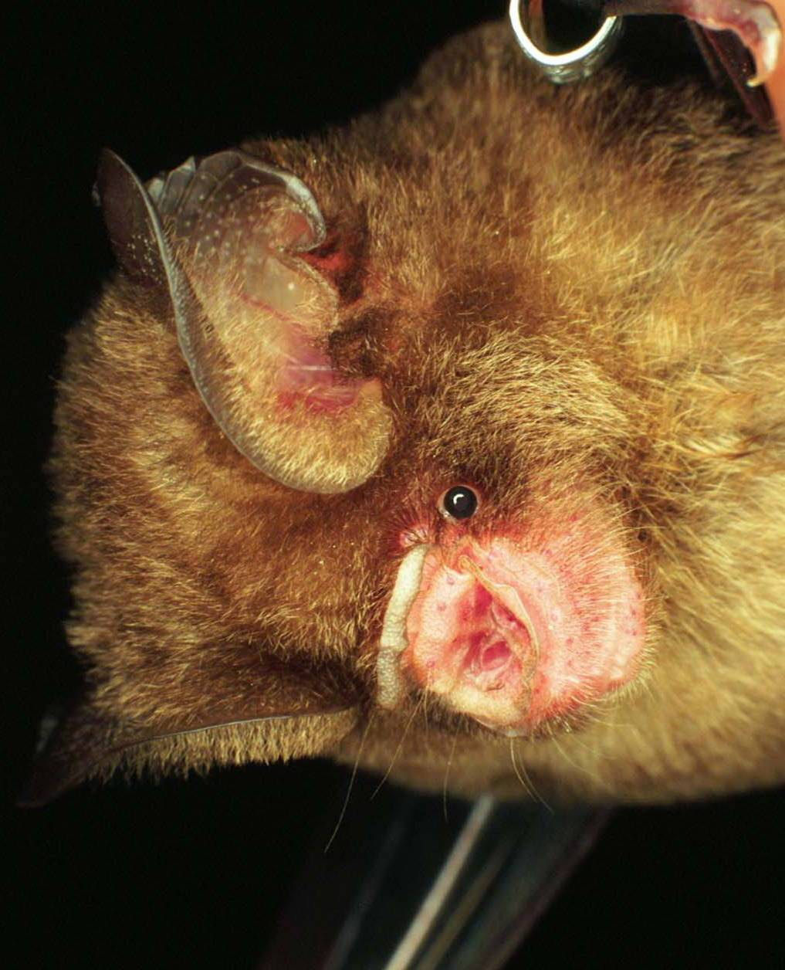
Hipposideros cervinus

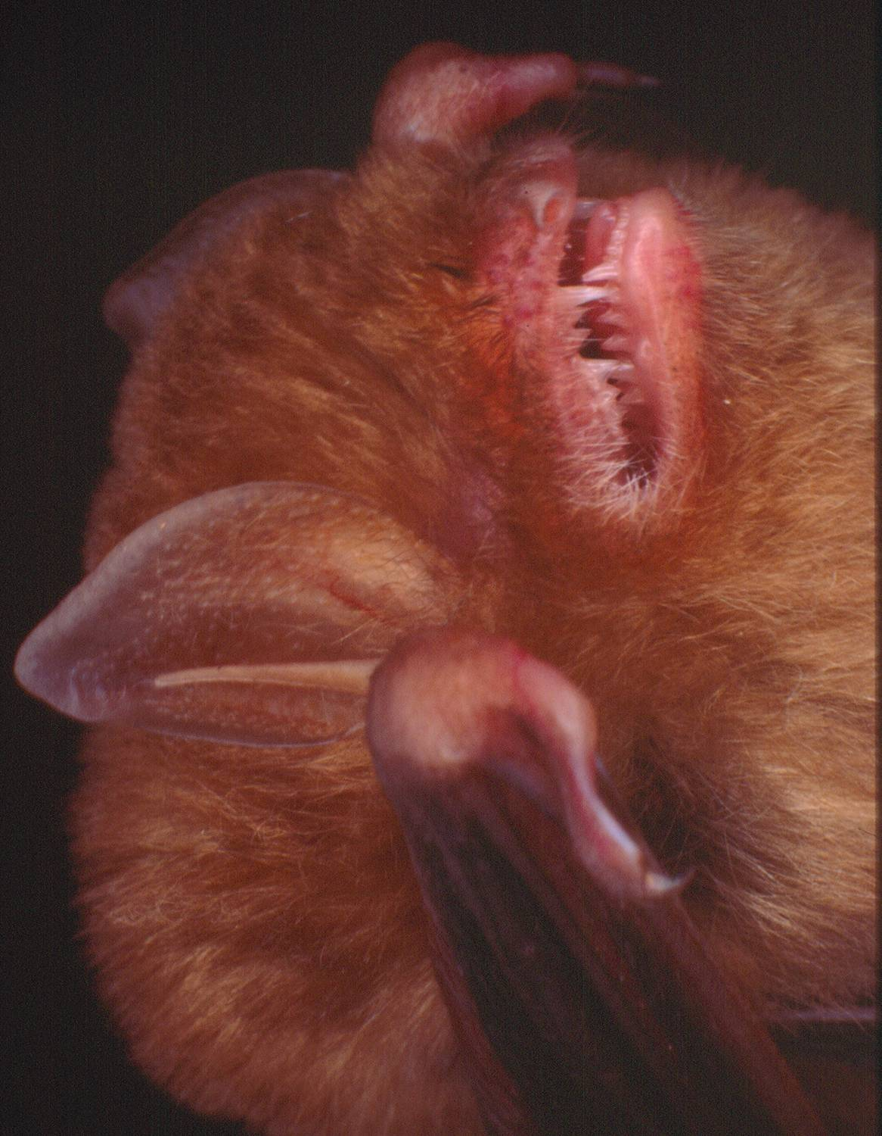
Kerivoula intermedia

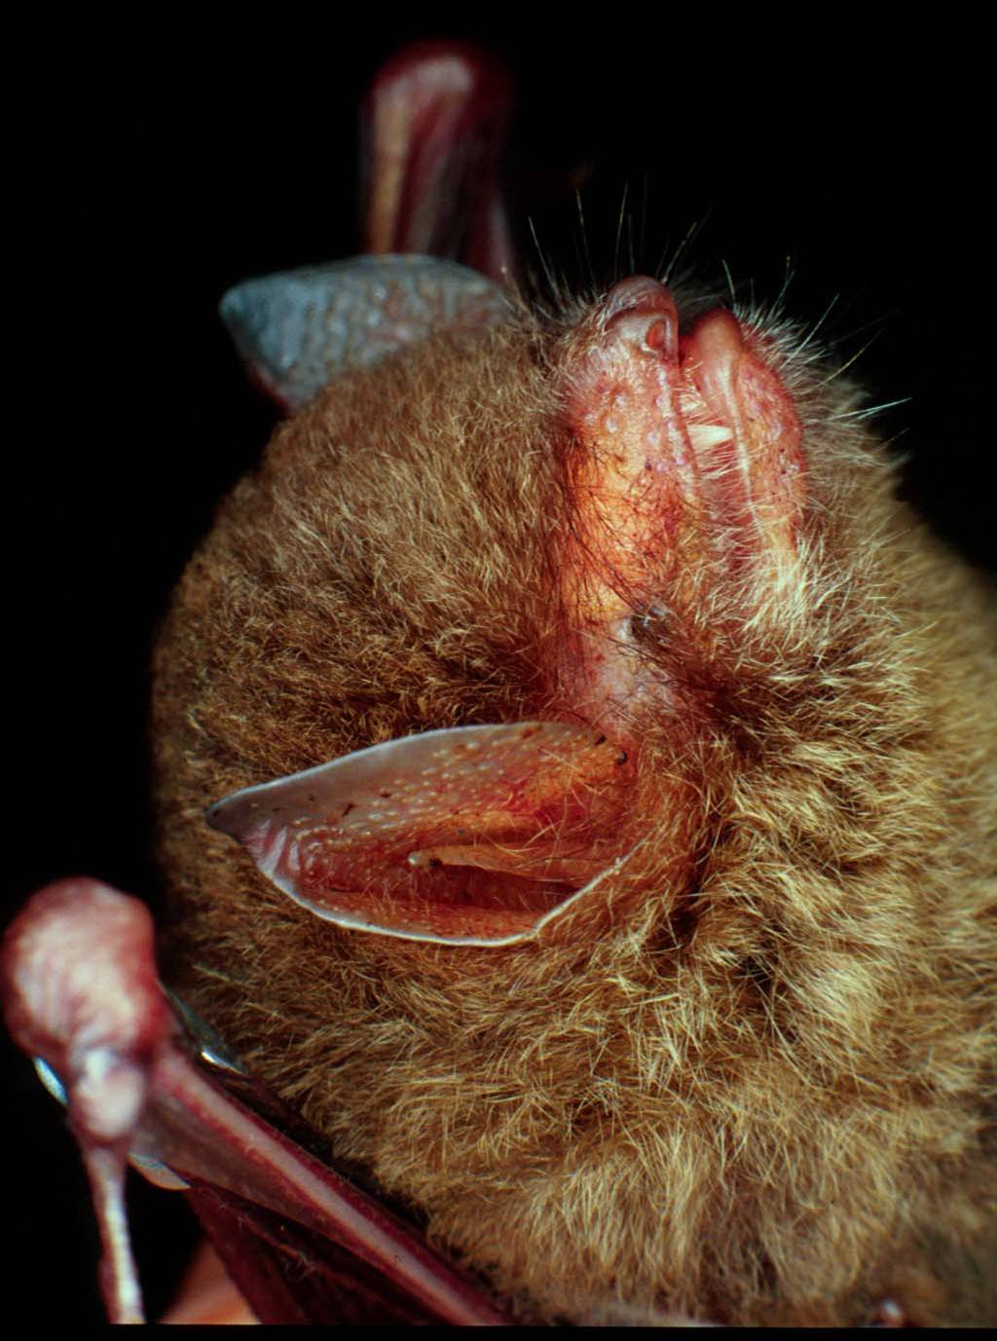
Kerivoula papillosa
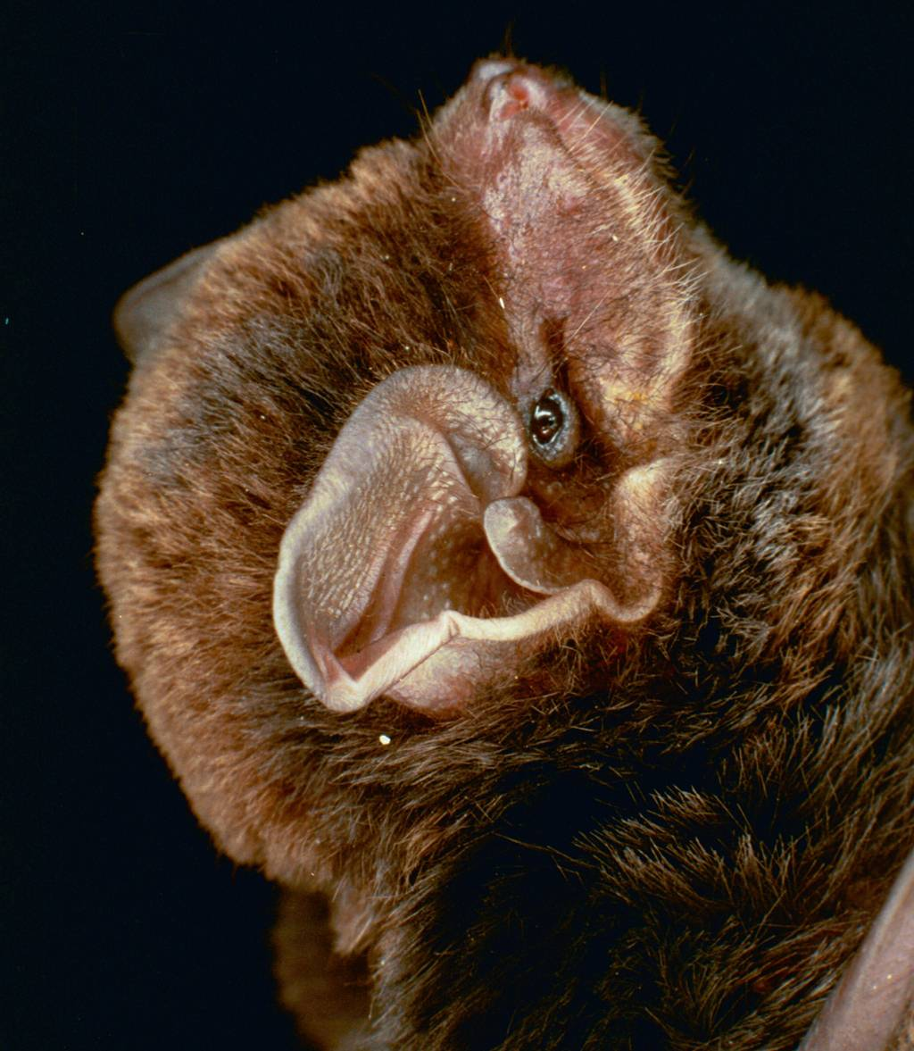
Miniopterus schreibersii

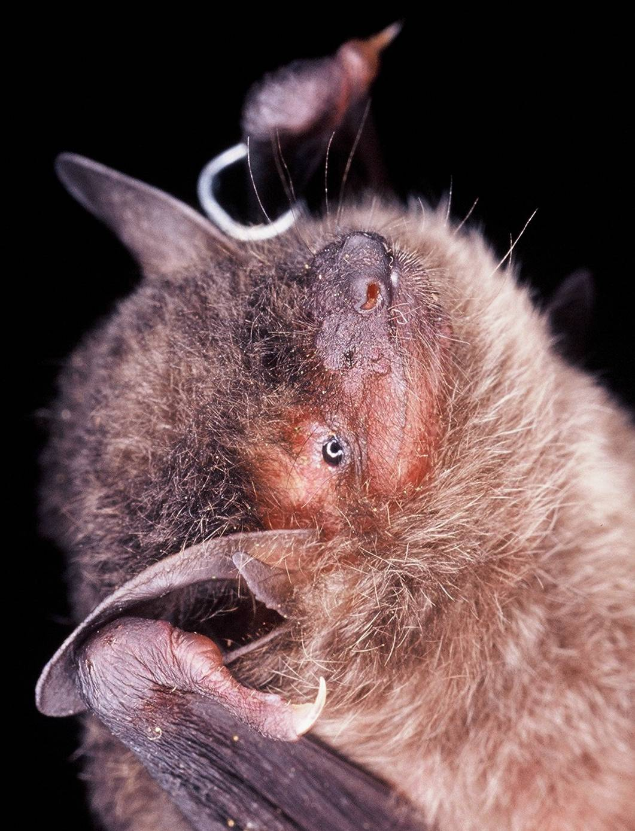
Myotis muricola
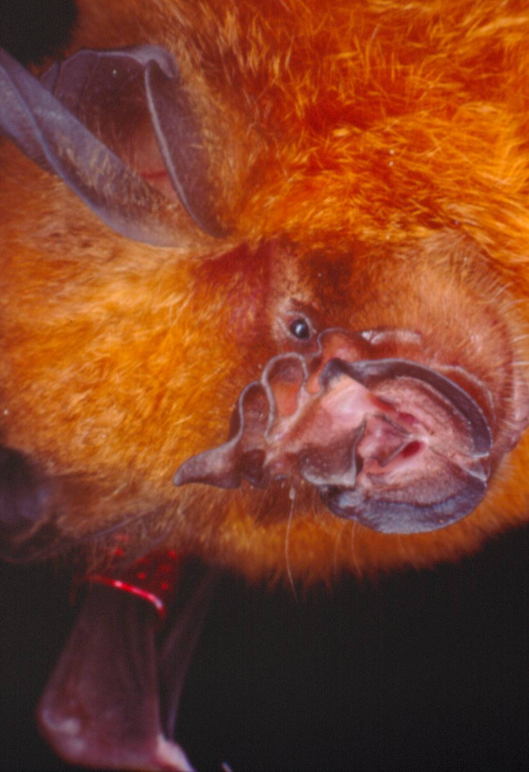
Rhinolophus stheno

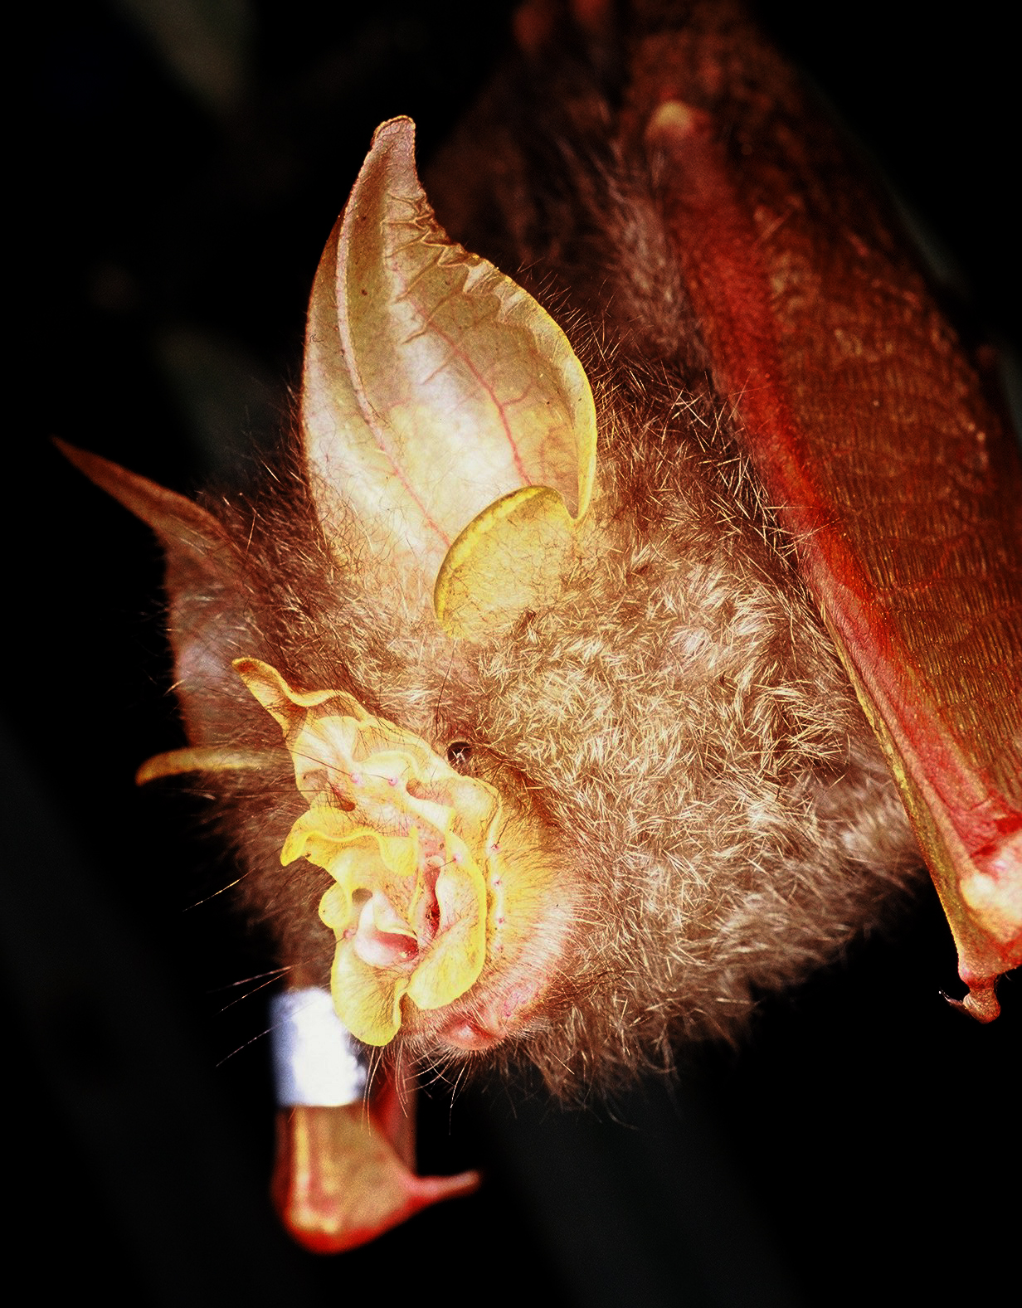
Rhinolophus trifoliatus

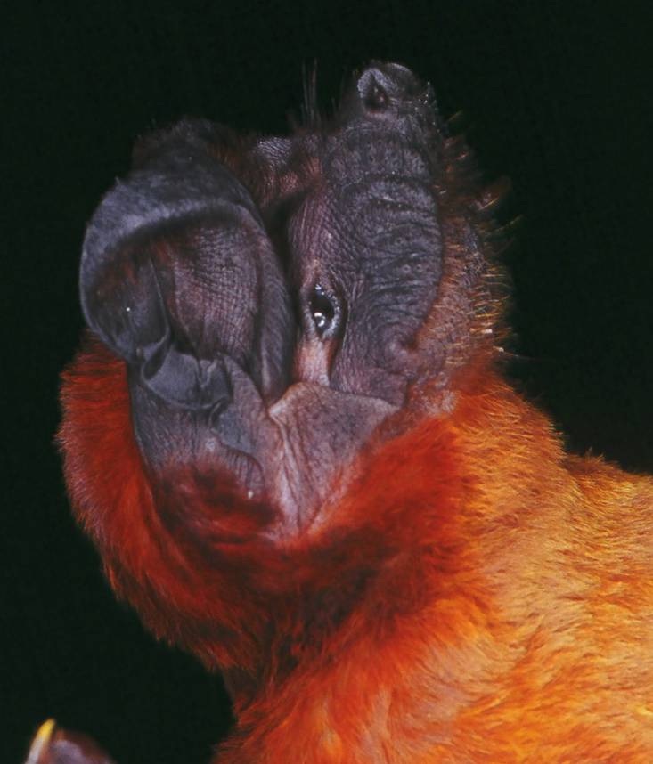
Tadarida mops
Bat Information Cards and Wing Traces
Cheiromeles torquatus

Hello! My name is Cheiromeles torquatus! I’m also known as the Naked Bat because I’ve got no fur – just a few small hairs on my chest. I am a mammal, have five fingers and I weigh 150-200g which makes me the biggest bat in the world to catch insects in the open sky! I love to eat insects and for that, I do not mind flying more than 70km a night, but then I can fly really fast! I sleep in tree hollows and caves with up to a thousand of my family and friends. My relatives live in Thailand, Malaysia, Philippines, Sumatra and Java.

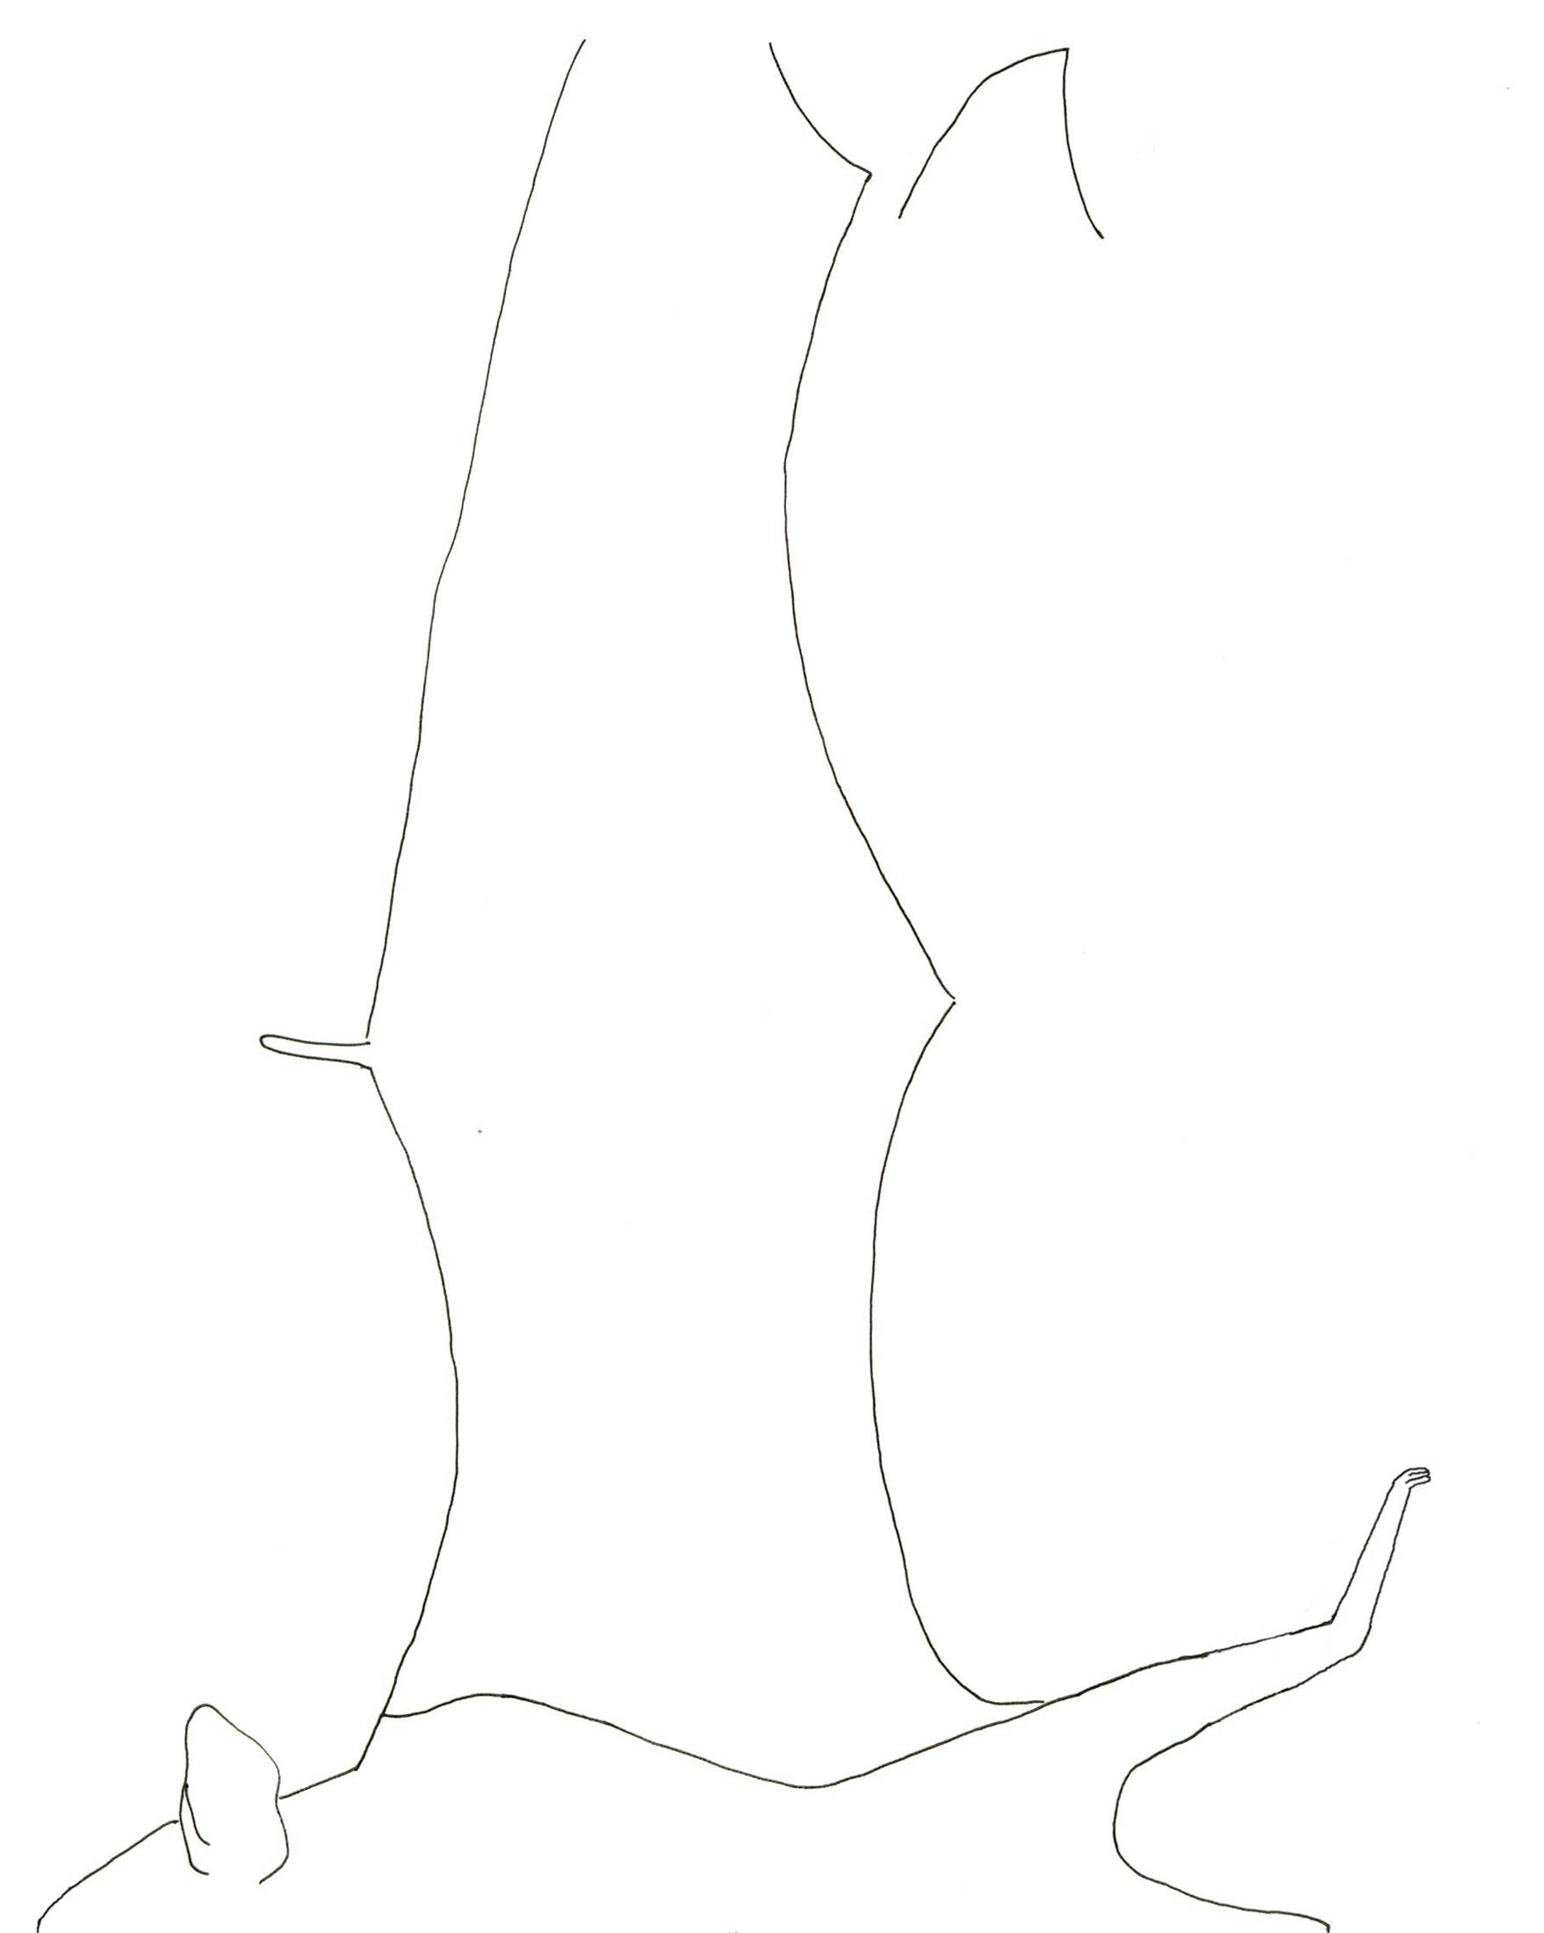
Cheiromeles torquatus
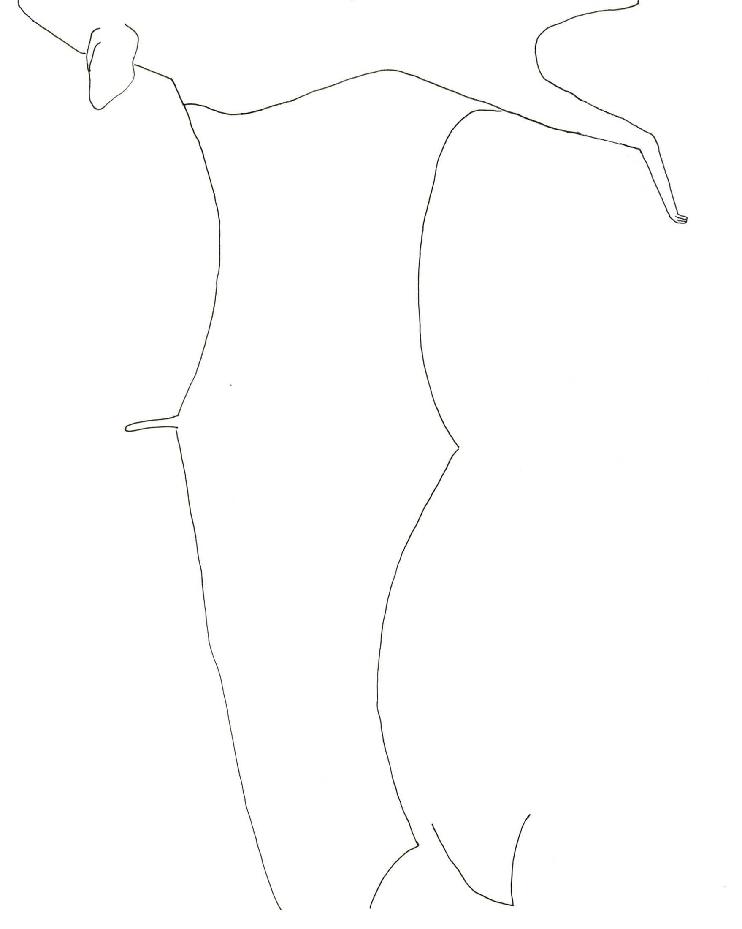
Cheiromeles torquatus
Emballonura monticola

Hello, my name is Emballonura monticola. My common name is “Lesser Sheath-tailed Bat”. I am a small mammal and weigh between 4-7g. I have a small tail and dark brown fur. I like to eat insects at the forest edge, or in gaps in the forest where a tree has fallen. Sometimes I like to live with about 10 friends under a fallen log in the forest, but other times I live in a cave with 100 others. My relatives live in Thailand, Malaysia, Sumatra and Borneo.

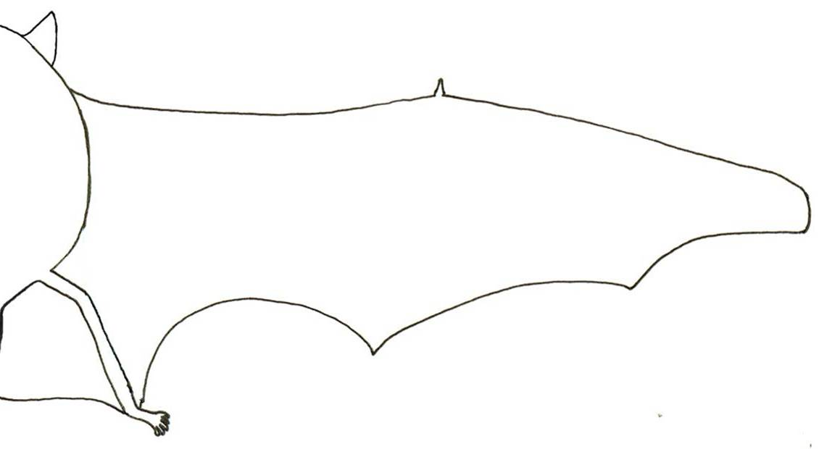

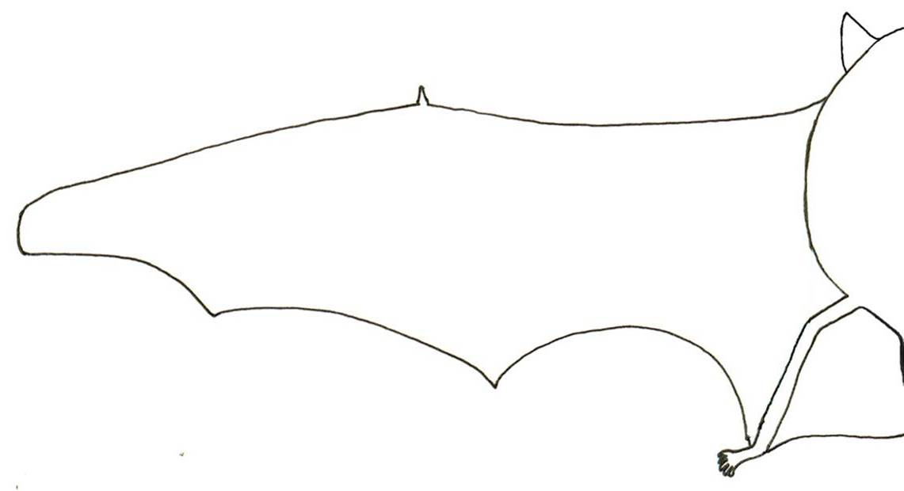

Emballonura monticola

Hipposideros bicolor

Hello! My name is Hipposideros bicolor. I am also known as the “Bicoloured Roundleaf Bat”. I am a mammal with five fingers. I only weigh 7-8.5g. I like to roost in caves with several hundred other Bicoloured Roundleaf Bats. My favourite food is insects. My species lives in Malaysia, India to Southern China, Taiwan and Southeast Asia.

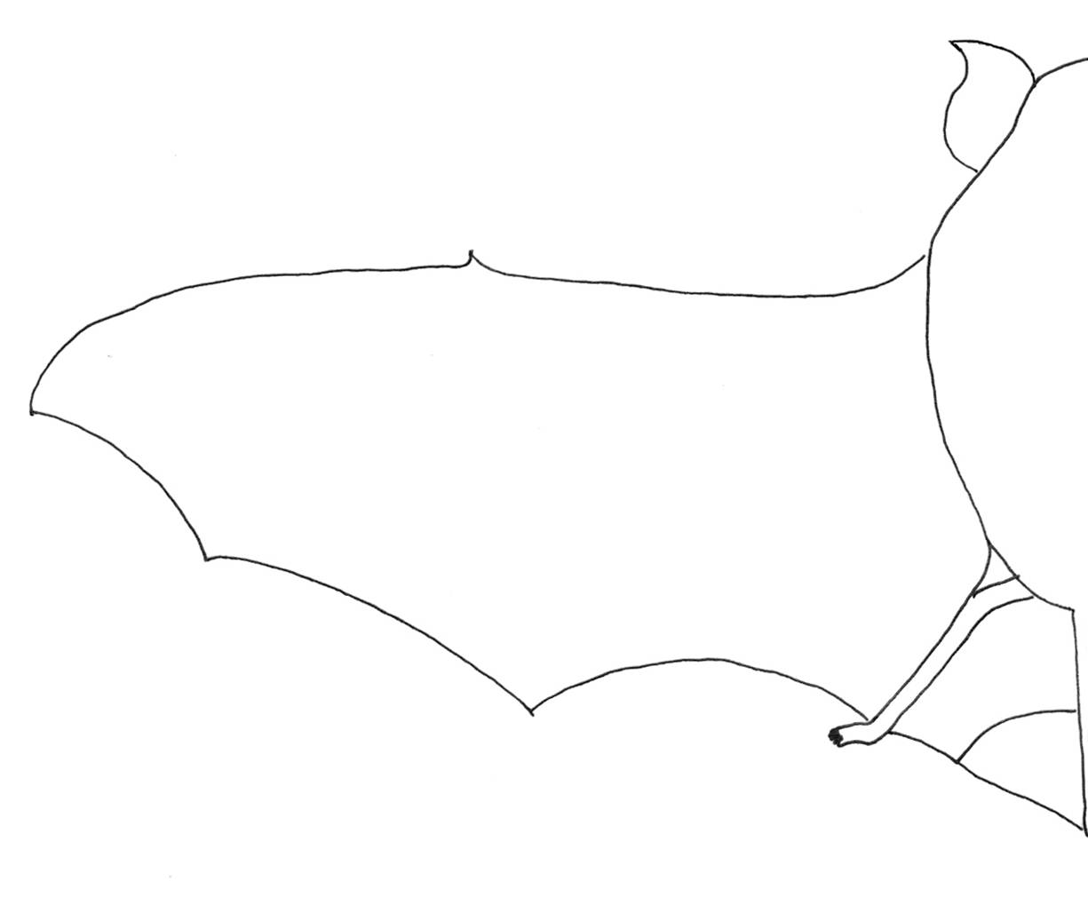
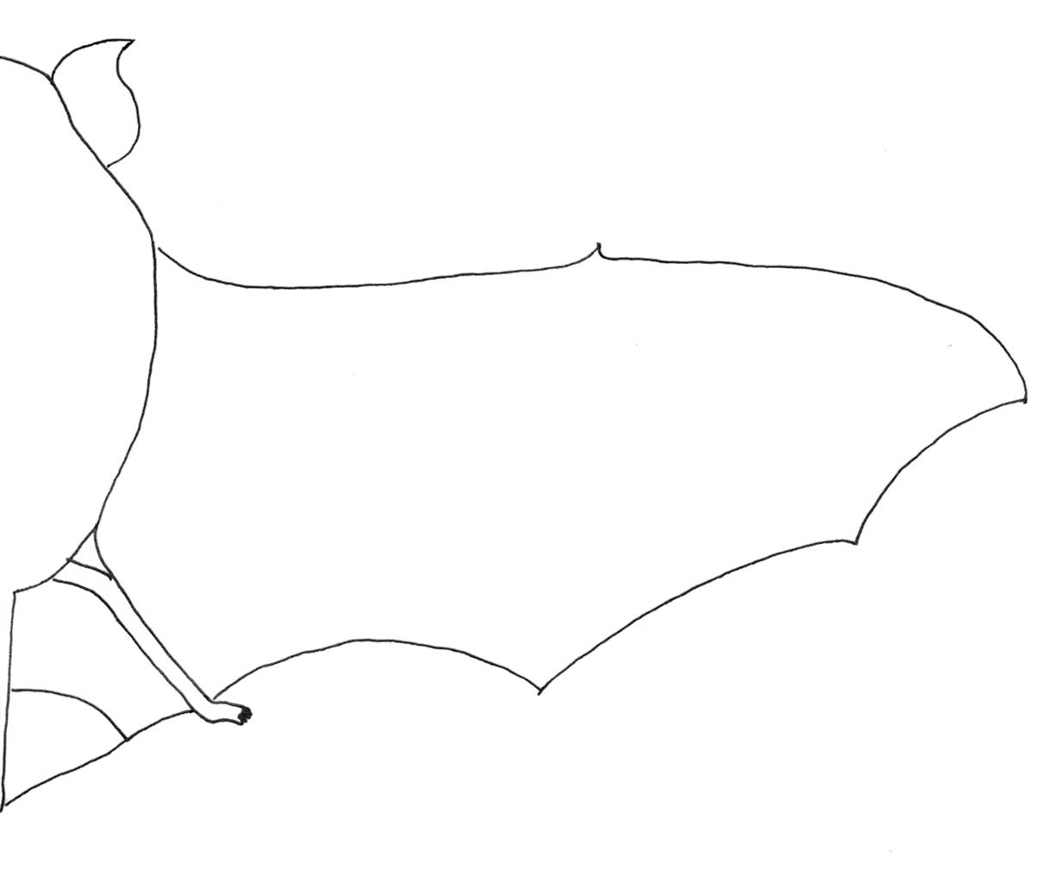
Hipposideros bicolor
Hipposideros cervinus

My name is Hipposideros cervinus. People also call me “Fawn Roundleaf Bat”, because my fur is the colour of a baby deer or fawn. I am a mammal. I weigh between 7-10g and have five fingers. I live in caves with a very huge gathering of family and friends - sometimes there will be up to 300,000 of us. I find my favourite food, insects in the forest understorey. You can find me in Peninsular Malaysia, Philippines through Indonesia and New Guinea to Australia.

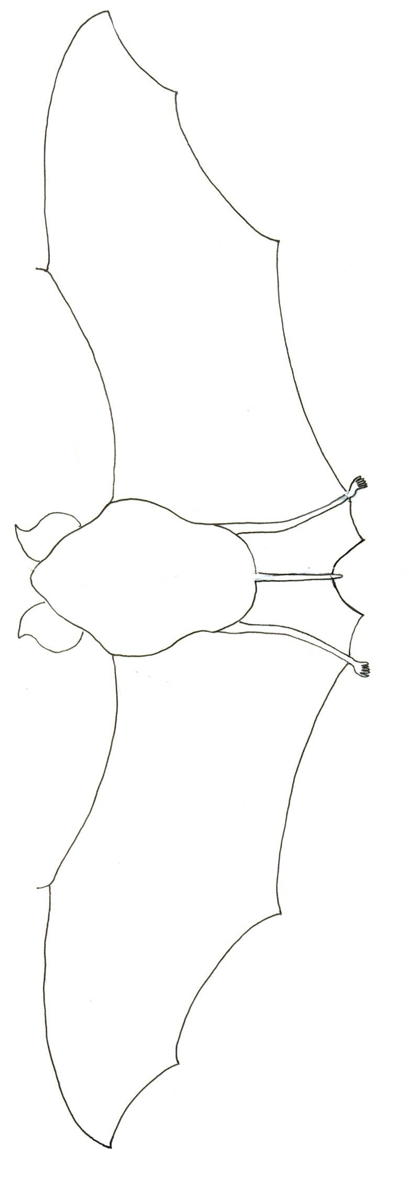

Hipposideros cervinus
Kerivoula intermedia

Hello! My name is Kerivoula intermedia. We are sometimes called Woolly Bats because of our long woolly fur. Although I’m pretty small – I weigh just 3.5-4g my wings are quite large so I can fly in and out of trees without hitting them. I love to eat small bugs that I find on leaves and branches. When I’m tired, I like to roost in dead leaves or in hollow trees, usually on my own. You can find me throughout Southeast China, Thailand, West Malaysia, Borneo, Java, Sulawesi, Philippines, New Guinea and possibly the Solomon Islands.
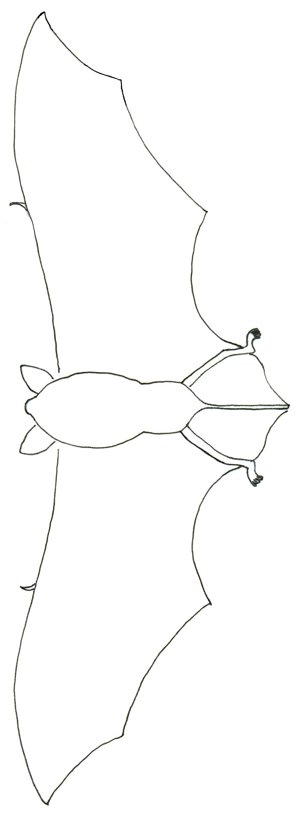
Kerivoula intermedia
Kerivoula papillosa

I am Kerivoula papillosa also known as “Papillose Woolly Bat”. I am bigger than my cousin Kerivoula intermedia! I weigh 6-13g. I am a mammal with five fingers. My favourite food is insects. I live in small hollow trees with 6 or 7 friends and even bamboo in countries like Northeast India, Indochina, Peninsular Malaysia, Sumatra, Java and Sulawesi.

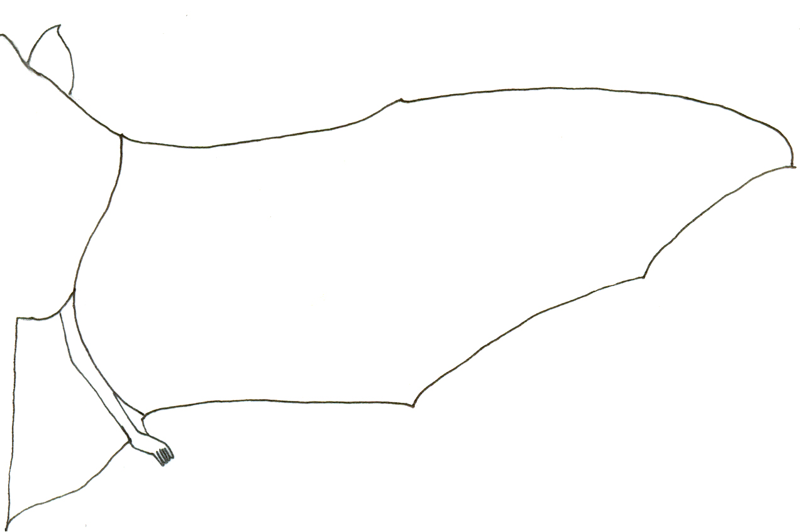
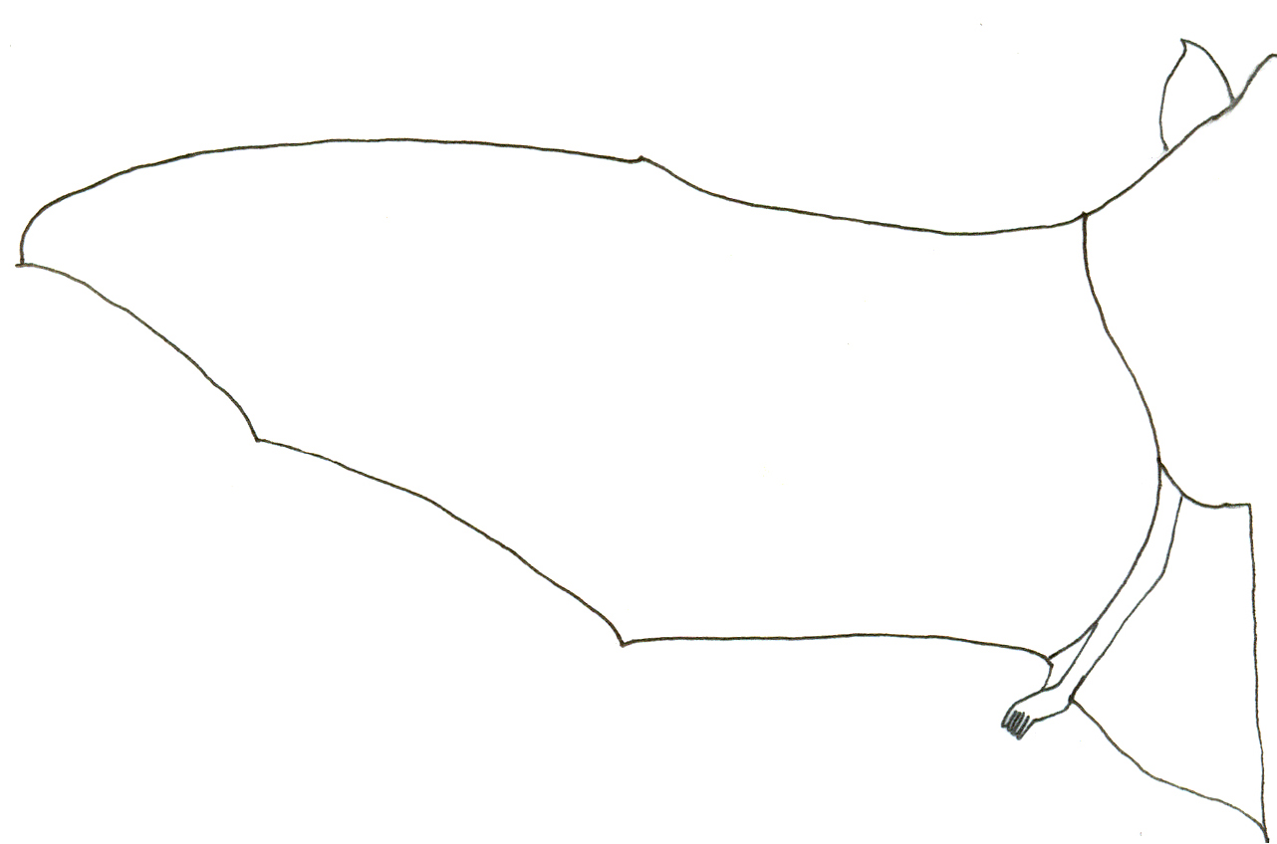
Kerivoula papillosa
Miniopterus schreibersii

Hello, my name is Miniopterus schreibersii but you can call me Schreibers’s Long-fingered Bat. I am a small mammal, weighing 10-12.5g with five fingers, but my fingers and wings are so long that I have to bend the tips over when I’m resting. But at least that makes it easy to tell me apart from other bats. I like to eat insects. I live in caves in a community of up to 100,000 other Long-fingered Bats. We can be found living in Africa and Europe through to Asia and Australia.

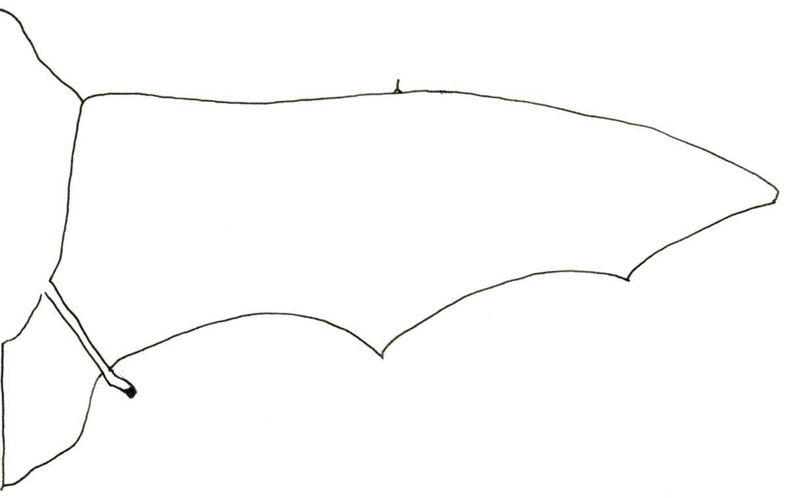
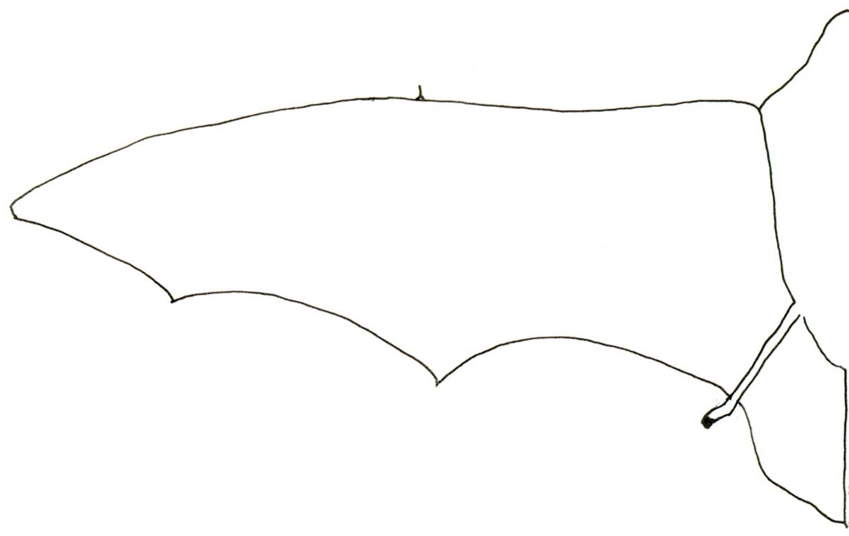
Miniopterus schreibersii
Myotis muricola

Hello friends! My name is Myotis muricola. I am also known as the “Whiskered Myotis”. I am a mammal with five fingers just like you! I weigh 4-5g. I live in small groups of 6-8 friends in furled central leaves of banana plants. Some of us have pointy ears! Most of us can catch insects while we fly. We often meet our friends, the Lesser Sheath-tailed Bats feeding at the forest edge and in tree fall gaps. We can be found in countries, such as Afghanistan through North India and Nepal to Taiwan, Vietnam, Malaysia, Indonesia, and New Guinea.

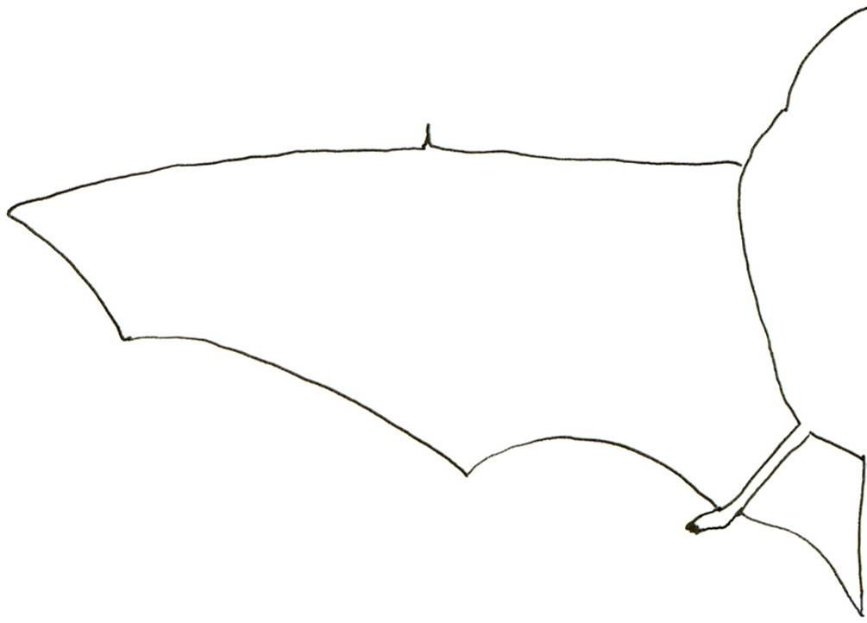
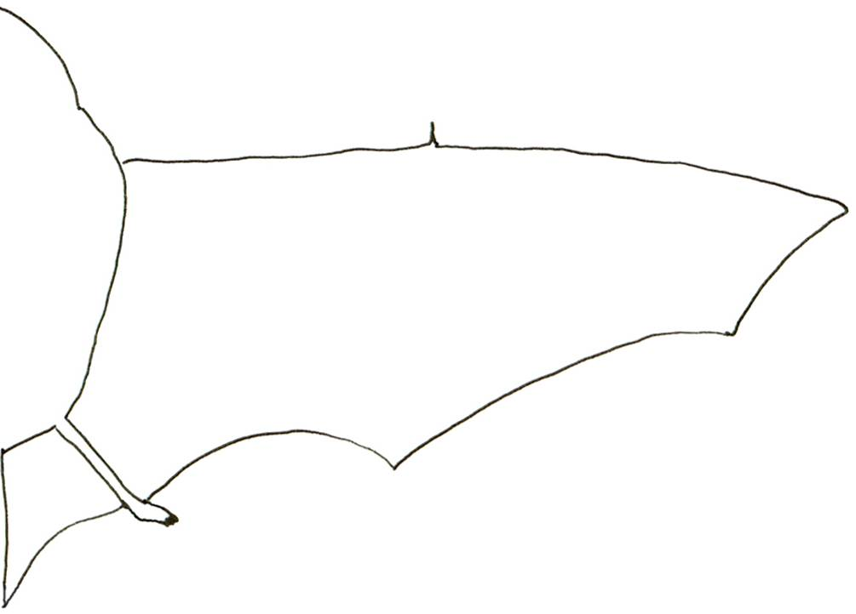
Myotis muricola
Rhinolophus stheno

Hi! My name is Rhinolophus stheno and I’m also called the “Lesser Brown Horseshoe Bat”. I am a small mammal with five fingers. Like my cousin, Rhinolophus trifoliatus, I also use echolocation to find my favourite food – insects! When I echolocate, I whistle through my nostrils and use my beautiful noseleaf to point the sound in the right direction. I can tell you where a moth lands even with my eyes closed! I weigh only 10g! I live in a cave with about 100 to 300 of my friends! I can be found in Vietnam, Thailand, Laos, Peninsular Malaysia, Sumatra and Java.

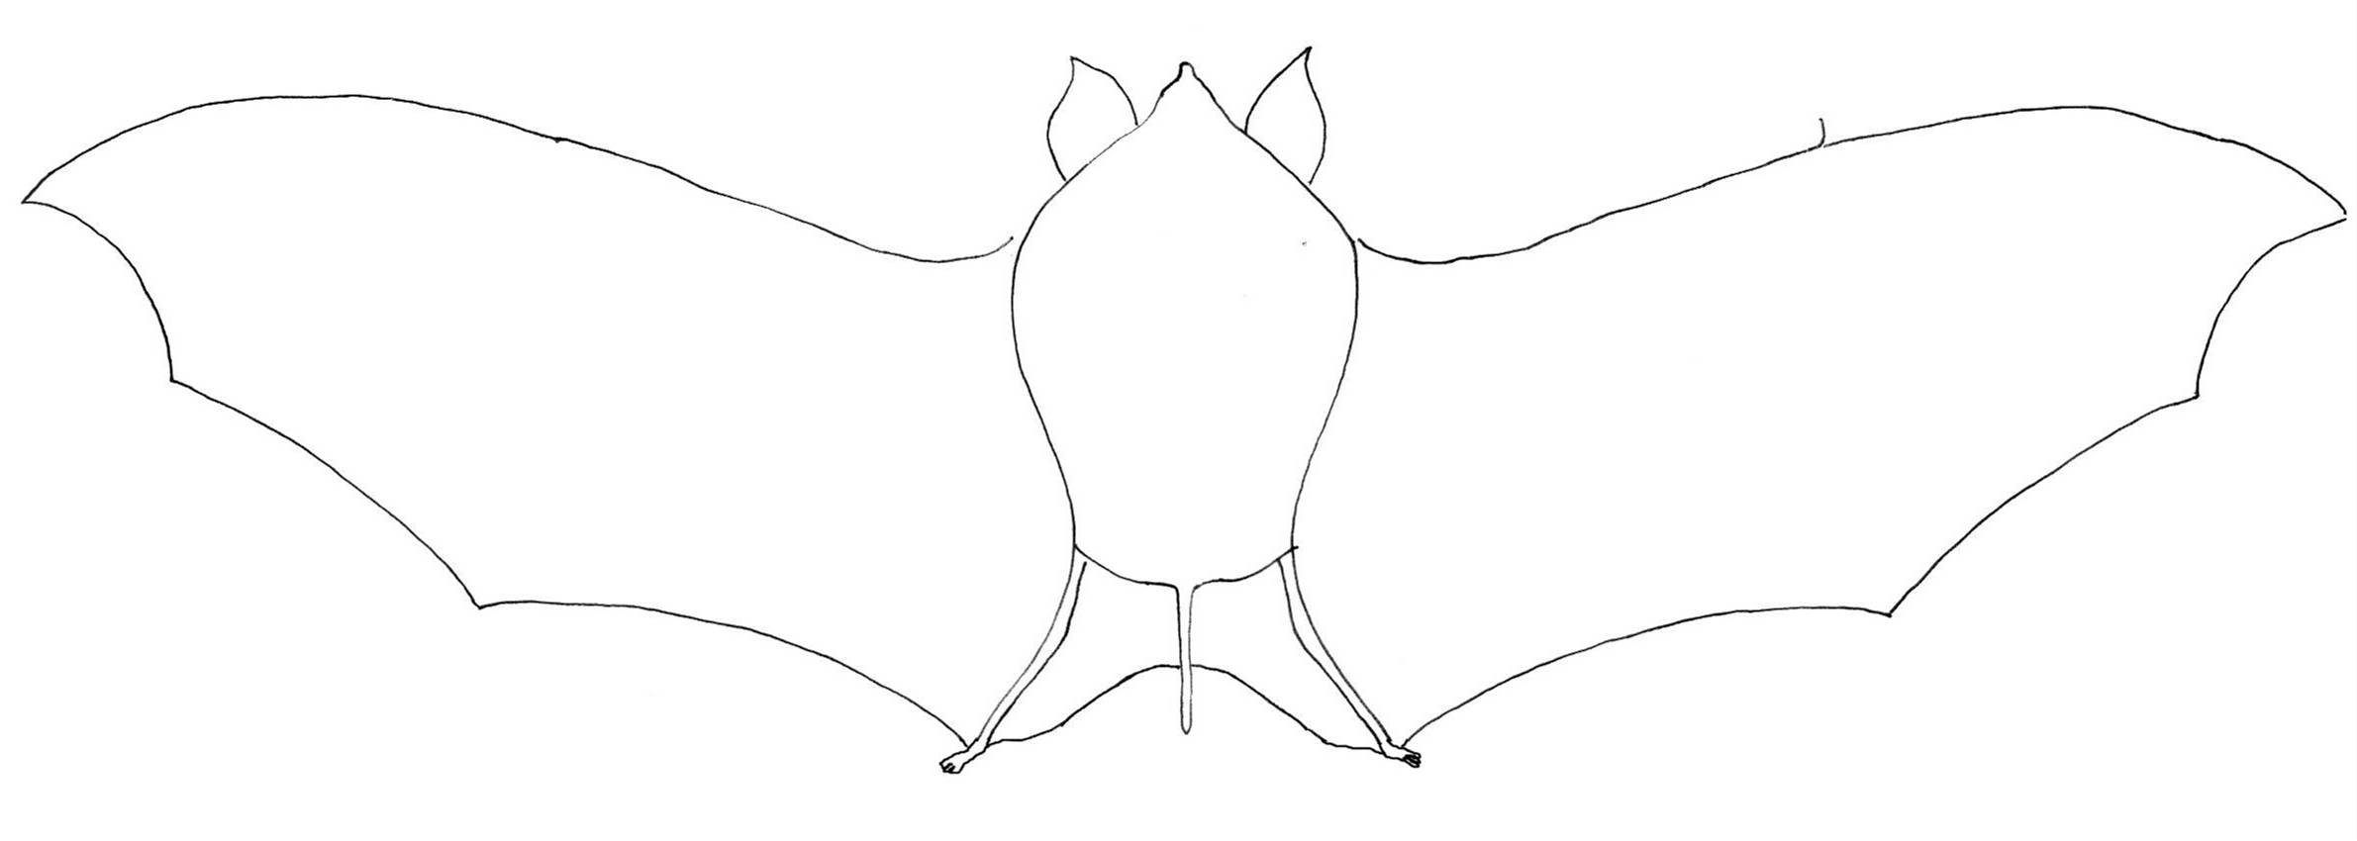
Rhinolophus stheno
Rhinolophus trifoliatus

Hello everyone! Although my name is Rhinolophus trifoliatus. I am much smaller than any rhino you’ve ever seen! I am also known as “Trefoil Horseshoe Bat”. I am a small mammal weighing only 10.5-18g! I use echolocation to find my favourite food – insects! I like to sleep on my own hanging from the leaves of palms or rattan in the forest. I feel safe there since my colouring makes it difficult for other animals to find me in amongst the leaves. My fur is a lovely grey colour, my wings are light brown and I have the most beautiful yellow nose, knees and elbows. I have five fingers just like you. I can be found throughout Northeast India, Southwest Thailand and Myanmar including Malaysia.

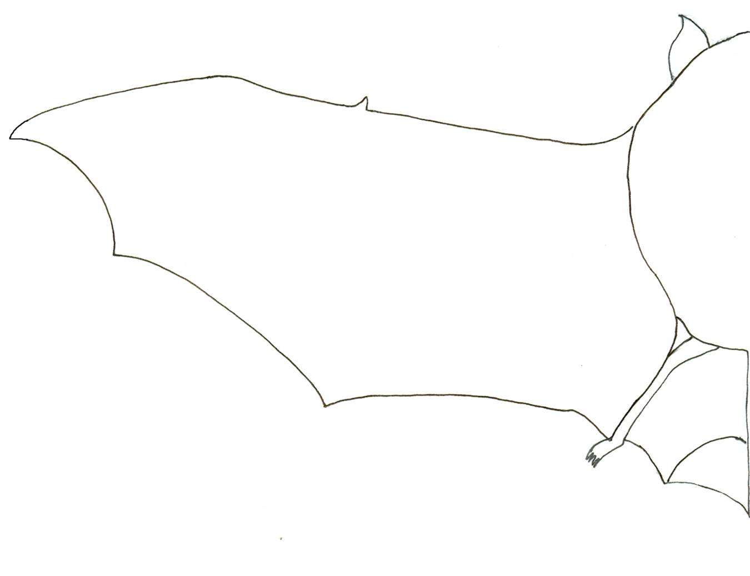
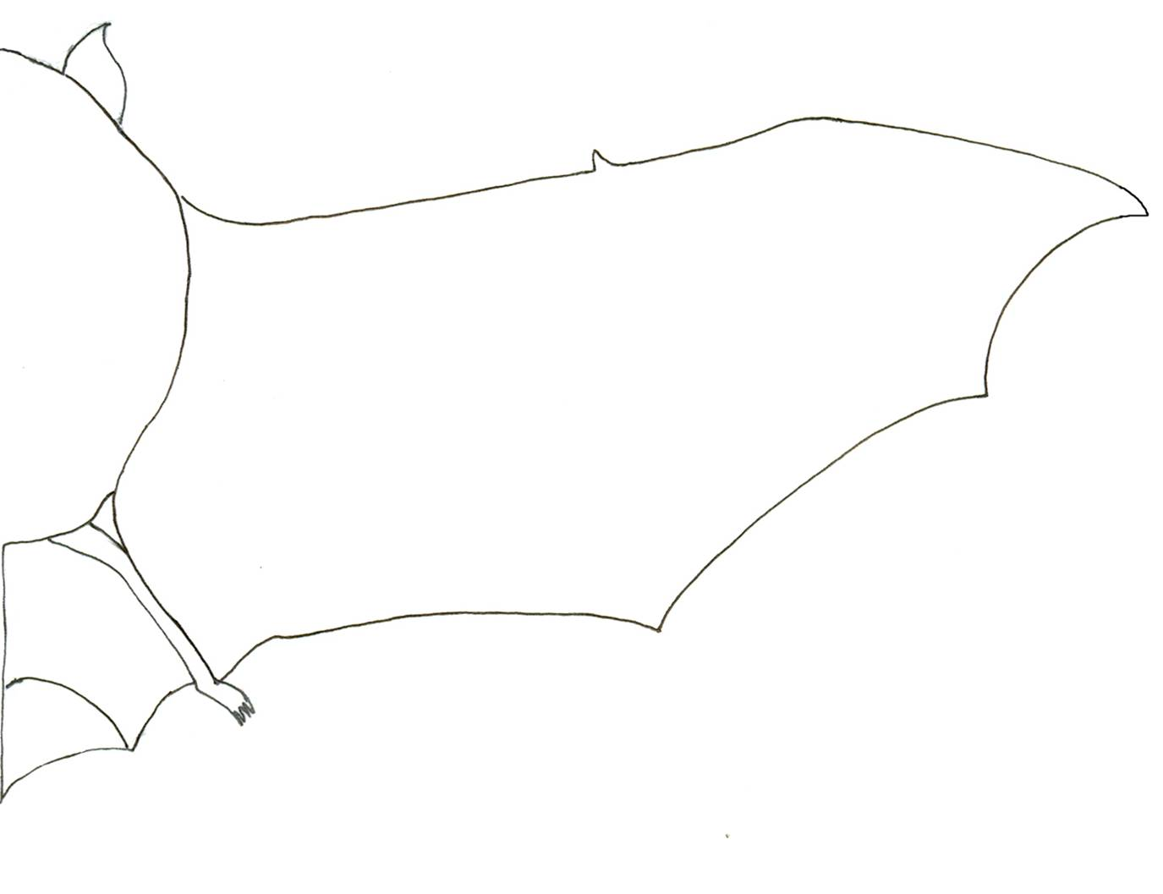
Rhinolophus trifoliatus
Tadarida mops

Hello everyone! My name is Tadarida mops also known as the “Malayan Free-tailed Bat”. I am a mammal with five fingers. I live in tree hollows and caves. I love to live in a colony in a cave with my friends and family sometimes numbering up to 1 million. My favourite food is insects and I eat lots of them! So you can think of me as a kind of natural pesticide. I weigh about 25g. Last but not least, I can swim! I live in Peninsular Malaysia, Borneo and Sumatra. My family lives all over the world like in India, Sri Lanka, South China, Hong Kong, Cambodia, Vietnam and Malaysia. If you visit USA, don’t forget to meet my cousin, Tadarida brasiliensis.

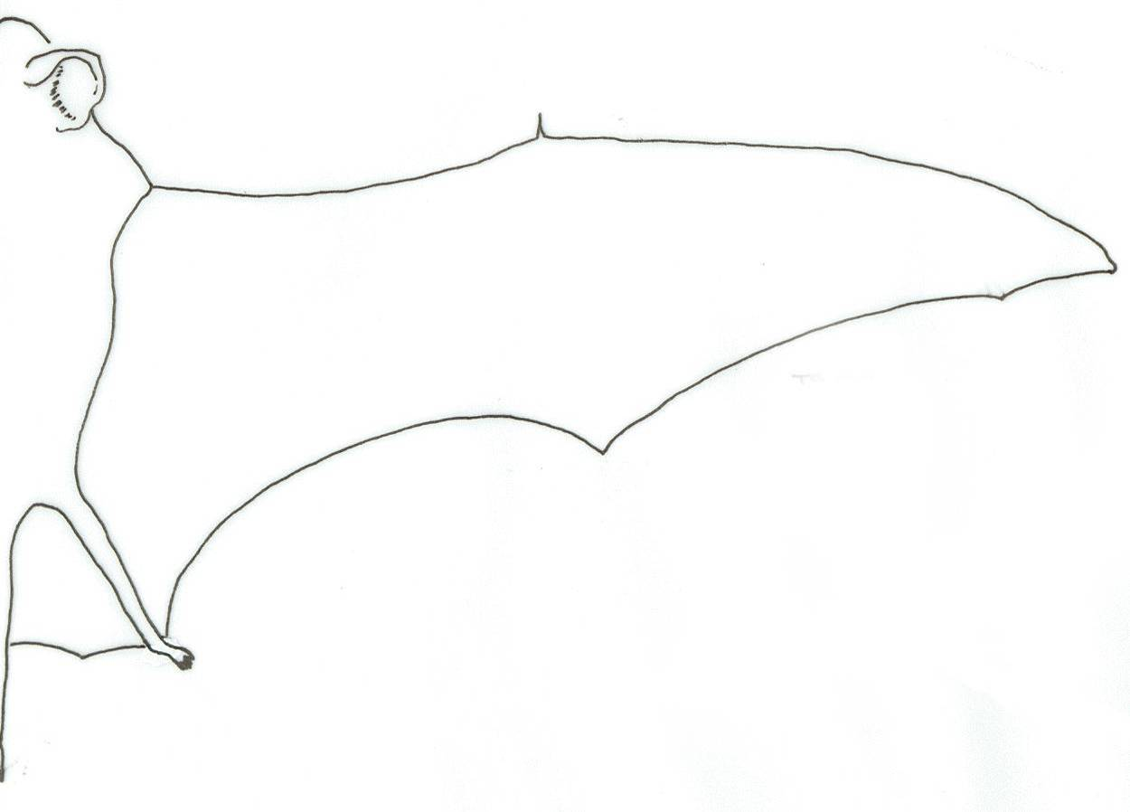
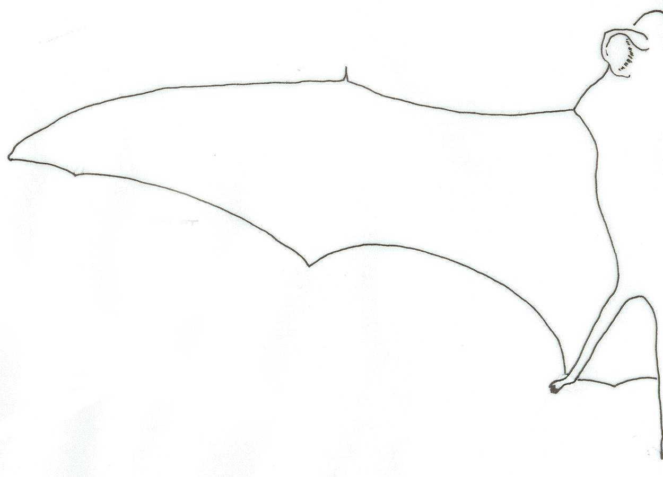

Tadarida mops
Comparison Table
(stick bat photo here) | BAT | ME

Formal Name

Common Name

Animal Type

Weight
Number of fingers on each hand
Favourite Food
Favourite Hangout

Lives with
Discussion Points for Educators
- What are the similarities between a bat and a child?
Like humans, bats also have a formal name and common name. We are also mammals with five fingers. Maybe some children would describe their favourite food as fruits. Like children, some bats live in small family groups too.
- What are the differences between a bat and a child?
Probably the most obvious difference is in the weight. While all of us use the kilogram measurement to describe our weight, most bats weigh less than 1 kilogram! Most children would also not list insects as their favourite food or favourite hangout as a cave or tree.
- What are the similarities between a bat’s wing and the human hand? Bats’ wings can be thought of as two layers of skin pressed close together, with an inner supporting skeletal framework. Bats have greatly elongated finger bones which form the primary support for their wing membranes. They also have a thumb.
- Why do bats look so different from each other?
One of the most fascinating aspects of bats is their facial anatomy. The great diversity of face types is due to their differences in lifestyle and diet. For example, bats that feed on nectar need long, thin faces to insert into flowers while bats that feed on insects have shorter muzzles and stronger jaws to chomp down on insects. Examine the other parts of the bat. Large eyes on a fruit bat help them see better in the dark, and a large, complicated noseleaf in an insect-eating bat helps it to echolocate.
- Do all bats live in colonies?
Not all bats live in colonies. However, there are obvious advantages to sharing a roosting site. For many species suitable roosts are in short supply, making colonial life the only possibility. Large colonies offer strength in numbers as well as efficient use of safe havens such as large caves. In addition, roosting in large numbers makes it easier to conserve body heat. Predator avoidance may also have determined the original tendency to from large groups. It is easier to spot predators when there are more individuals on the watch for them and able to sound the alarm when one is spotted.
The Puppet Show

The puppet show is the highlight of the day. It is a great tool that can introduce basic concepts about bats in a fun and attractive way and paint a friendly picture of bats. Gema’s Home, the story provided in this guide, can be used and the comic of the same story distributed as a gift at the end of the party.

Bat Information for Educators
There are 1111 different kinds of bats in the world and they eat a variety of food items. The diversity of diets is not only interesting, but what and how bats eat are vital to the ecosystems of the world.

About 70% of bats are insectivorous. They are major predators of insects, including mosquitoes and crop pests. Nursing mothers are able to eat as much as their body weight in insects nightly. Bats capture their prey using echolocation (sonar). Insects may be caught directly in the mouth, deflected towards the mouth with the wings, or captured in the tail membrane. Bats in large numbers provide valuable insect and pest control, chemical free and at no charge.

Nectarivorous bats feed on nectar and pollen and serve as pollinators for a variety of trees and shrubs. Bats are especially important in rainforests, where their pollination activities help maintain the diversity of plant life. When a bat inserts its head into a flower to obtain nectar, its head and body become covered with pollen. As it moves among flowers, the pollen stuck to the bat’s fur is transferred to flowers on other plants, effecting cross-pollination.

Fruit bats are also extremely valuable to the maintenance and regeneration of tropical rainforests. Some fruit bats eat up to two and a half times their body weight in food in a single night. Attracted by the odours of ripe fruit, the frugivorous bat picks a fruit with its mouth and flies off to eat its dinner. They chew the fruit but only swallow the nutritious juices and pulp; the fibre and seeds are spat out. By discarding undigested seeds, bats help to distribute them to different parts of the forest. A small percentage of these will take root and grow into new trees. Fruit bats are also vital to forest regeneration in clear-cut areas, because they do cross clearings, dropping seeds as they fly. A high percentage of woody plants that grow in cleared areas come from seeds dropped by bats.

Objectives:
To introduce the importance of bats.
Materials:
Puppet Templates
Acetates (overhead projector, OHP paper)
Scissors
Permanent or paint markers
Poster colours to paint the backdrop
Stiff thin wire 4mm diameter
Pliers
Round fasteners
Cellophane tape
White cloth 2m x 1m
Frame 2m x 1m
100 watt light bulb and cable to wire to nearest socket
Tarpaulin or any large cloth (to hide the puppeteers)

Instructions:
Activity preparation
- Print out the templates on page 74-83 onto acetates or overhead projector (OHP) paper (Some figures need to be enlarged. Certain figures, e.g. banana leaves, durian etc. may be printed on coloured acetates)
- Cut out the figures.
- Colour the figures with permanent marker (We recommend paint markers. Ensure that light from behind can shine through the colours, creating something similar to a stained glass effect).
- Cut some stiff thin wire, 4mm diameter. Each wire should be stuck onto the figures with cellophane tape strategically, so the wire is not too visible. Allow an extra length of at least 70cm to 80cm of wire from the figurine for handling. Depending on the size of the backdrop, you may adjust the length of the wire (remember that the bats fly, so provide more length of wire for their characters). Nur and Mr Aziz’s arms should be held together by round fasteners at indicated points. Wire should be attached to the forearm and fingers, so that you can manipulate hand movement.
- Reinforce the handles by bending the wire to form a U-shape, then wrapping with masking tape, for easier handling.
- Set the stage by spreading the backdrop (ensure it is taut) against a frame.
- Prepare the backdrop with a forest scene that includes a tree with a hollow and a cave with flowers growing around it.
- Place the 100 watt light bulb above and behind the stage at a distance of about 1m.
- Use a tarpaulin or any large piece of cloth to hide the puppeteers hiding behind and underneath the frame.
Tips
Place sheets of paper between the figures when storing to protect the figures from scratching against each other.

Steps:
- Choose 6 children to be puppeteers and train them before the party. Choose another 6 children to be the voices of the characters. (Alternatively the educator and 3 or more assistants could put on the show if children are not available to train in advance. Prerecord the script if there are not enough people).
- Delegate characters to the puppeteers involved. Each puppeteer should also have a “voice” partner (choose the most appropriate child or person for each character).
- The puppeteer and his/her corresponding voice should be able to work together and are advised to read the scripts aloud together.
- The “voices” of the puppeteers are advised to read through the script several times. Ensure the “voices” are loud and dramatic.
- Practise the puppet show further, if possible with the stage and microphone.
- When organising the area for the party, set up the stage in advance and test the electrical equipment.
Tips
Laminate the script and punch two holes at the top of it. Hang the script on nails in front of the children. Have a helper to turn the pages during the show.

GEMA’S HOME

SCENE 1
Stage Direction

Nur with bananas.
SFX: rong rong rong!

SFX: rong rong rong!

Gema flies around in circles.

Nur talks to Gema in surprised tone.

Gema flying in a panic.

Nur follows Gema.
Mr Aziz with chainsaw near tree with hollow.

Nur talks to Mr Aziz.

Gema flies up to Mr Aziz.

Gema gestures towards tree.

Narrator: Early one sunny morning, Nur was gathering bananas from her garden from the edge of the forest. In the distance, she could hear a chainsaw.

Nur: Oh! What is that noise? It sounds like a chainsaw!

Narrator: Suddenly, a little bat flew past her. It was her friend, Gema. Gema was in a panic, flying round in circles.

Nur: Gema? Why are you this time of day? You should be resting!

Gema: I know! I know! I was in my roost grooming and resting when I heard this horrible noise. There’s a man with a chainsaw. He’s going to cut down my home. Help me Nur! Come and see!

Narrator: Nur followed Gema into the forest. They soon came across Nur’s neighbour Mr Aziz who was about to cut down a tree with a chainsaw. (Tree has a big hollow)

Nur: Mr Aziz! What are you doing? Please stop! Don’t cut that tree down, it’s Gema’s home!

Mr Aziz: Gema? Who’s Gema?

Gema: Me!

Mr Aziz: Ugh! What is that little thing?

Gema: I’m a bat! I live in the hollow of that tree. Please don’t cut down my home.
Mr Aziz: Why shouldn’t I? You can go and find another home! I want to sell the wood to the timber merchant. What use are bats? Besides you’re soooo ugly!
Mr Aziz talks to Gema.

Nur talks to Mr Aziz.

Nur and Mr Aziz follow Gema.

Nur: Mr Aziz! How rude! She’s not ugly! Just unique! I think she’s beautiful! Just look at that amazing nose and long fingers! I wish I looked like that! I would be able to fly around the forest! Just imagine!

Gema: You want to know why bats are so important? Follow me! I’ll take you to see some of my other batty friends. They normally rest during the day too but I’m sure they won’t mind us paying them a visit.

SCENE 2

Mr Aziz follows Nur and Gema.

Mosquito flys around Mr Aziz and Nur.
SFX: Zziiiiiiiiiii.
Mr Aziz and Nur swats them.

Mr Aziz talks to Gema.

Mosquito flies around Mr Aziz.

Gema chases the mosquito, swoops through the air and catches the mosquito.

Mr Aziz talks to Gema.

Narrator: Mr Aziz, a bit confused, followed Nur and Gema into the forest to look for more bats.

Mr Aziz: (Muttering to himself) Silly bats stopping me from my work!

Narrator: On their way through the forest, Mr Aziz and Nur were plagued by mosquitoes. They swatted them as they walked.

Mr Aziz: Ok, Gema, why are bats so important?

Gema: Well, I’m an insectivorous bat

Mr Aziz: A what bat?

Gema: Insectivorous. That means I eat insects. That’s why I have this huge funny shaped nose. I whistle out of it and from the echo I can tell where things are, even in the dark. Watch this!

Narrator: Gema demonstrates her echolocation skills. She swoops through the air and catches a mosquito that is about to munch on Mr Aziz.

Mosquito: (Mosquito screams just before it is eaten) AIIIEEEEE!!!

Mr Aziz: Is it gone? I can’t hear it anymore! (Convinced) Thank you, Gema! I’m glad you’re here! I thought you bats were all just pests who raid our crops and spread disease!

Gema: What a load of nonsense! You humans are all the same! You’re afraid of what you don’t know!

Nur: So is that why you come out at dusk and dawn, because there are more insects?
Nur talks to Gema.

MrAziz talks to Gema.

Nur talks.

Gema talks.

Gema: That’s right Nur, more food! In fact some times I feel a bit greedy and go a bit mad.

Nur: What do you mean Gema?

Gema: Well my record is 600 mosquitoes in an hour!

Mr Aziz: Wow! You’re one mean mossie-munching machine!

Nur: So the more bats there are the less we will get bitten by these horrid insects.

Gema: See, bats are important! We eat insects! We’re fantastic pest control!
SCENE 3

Gema, Nur and Mr Aziz walk towards the cave.

Mr Aziz talks to Gema.

Gema wakes Polly.

Mr Aziz talks to Polly.

Nur talks to Polly.

Mr Aziz talks to Polly.

Nur talks to Mr Aziz.

Gema talks to Polly.

Mr Aziz talks to Polly.
Narrator: The three arrived outside a cave in the forest.

Mr Aziz: Do all bats eat insects?

Gema: No we don’t. Let me introduce you to my friend Polly. She lives in this cave. She eats nectar and pollen. Polly! Polly! Wake up Polly!

Mr Aziz: Goodness! Look at your long nose! And that tongue! I’ve never seen anything like it!

Polly: Sshh! You’ll wake my baby! I’ve been up most of the day feeding him milk and grooming him. He’s just nodded off to sleep, finally! What are you doing out this time of day anyway?

Nur: Gema’s roost was disturbed by Mr Aziz. He wants to cut her tree down to sell it to the timber merchant. He doesn’t think bats are important so Gema is showing us why humans need bats!

Mr Aziz: Gema eats insects that annoy us. That’s quite useful, but I can’t see how you can be of any use to anyone living in such a dark, damp, smelly place!

Nur: How rude! This cave is nice and cool.

Gema: Tell him what kind of bat you are Polly.

Polly: I’m a nectarivorous bat.

Mr Aziz: A what bat?

Polly: Nectarivorous bat. That means I drink nectar and eat pollen from flowers. That’s why my nose and tongue are so long so I can reach into flowers! My favourite nectar is from the durian flower.

Nur talks to Polly.

Flashcard pops up. Polly moves from one flower to another and lands on durian. She also visits flowers at the side of the cave.

Mr Aziz talks to Polly.

Gema and Polly talk.

Mr Aziz talks.

Polly motions towards Fruity.

Nur: Wow! I thought only bees and butterflies drank nectar. So does that mean you pollinate them too?

Polly: That’s right. When I feed I nestle right into the flower and get covered in pollen. When I go to other plants it rubs off into them. This makes the plant produce fruit.

Mr Aziz: My favourite fruit is durian. You help us make durian! That’s amazing!

Gema and
Polly: See bats are important!

Polly: We pollinate fruit plants so there is fruit.
Mr Aziz: Don’t bats also eat the fruit?

Polly: Yes, our friend Fruity the fruit bat does that. He lives in the top branches of the tree over there. Go and ask him about it.
SCENE 4

Fruity is in the top of the tree.

Mr Aziz talks to Fruity.

Fruity is sobbing.
SFX: Sobbing.

Gema talks to Fruity.

Fruity talks in frightened voice.

Nur talks to Fruity.

Mr Aziz talks to Fruity.

Gema exclaims in disgust.

Fruity talks.

Nur talks in sad voice.

Fruity talks to Gema.

Mr Aziz talks to Fruity.

Narrator: Nur, Mr. Aziz and Gema leave the cave and walk through the forest to find Fruity. The big fruit bat was in the top of the tree.

Mr Aziz: My goodness! You’re much bigger than Gema and Polly! Your face looks like a dog’s too.

Fruity: That’s no way to disturb a bat in the middle of the day! By insulting him!

Gema: Hey Fruity, what’s wrong? Why are you crying?

Fruity: Oh Gema, I’m so frightened. Last night, these people turned up with guns.

Nur: Guns? What for?

Mr Aziz: Yes! I heard big fruit bats are good for hunting. I’ve heard people saying it’s fun to shoot them!

Gema: That’s horrible! Shooting bats for fun?

Fruity: There used to be thousands of us living here, now there are only 50 of us left!

Nur: That’s so sad!

Fruity: Why are you up this time of the day anyway, Gema?

Mr Aziz: Gema has been showing us how bats are useful to humans. Insectivorous bats eat annoying insects, nectarivorous bats pollinate flowers to make fruit. But you, I’ve heard you eat fruit from plantations. You’re a pest yourself.

Nur: Hang on Mr Aziz! You’ve got it all wrong! Haven’t you worked it out by now? Humans need all bats! Tell him Fruity.
Nur talks to Mr Aziz.

Fruity is eating banana and talks with mouth full.
SFX: Munching.

Fruity continues talking with his mouth full.
Swoops across the stage
SFX: Farting.

Gema, Fruity and Nur laugh.

Fruity talks.

Gema talks to Fruity.

Fruity spits.
SFX: Spitting.

Fruity: For instance, I only eat over-ripe fruit.

Nur: Farmers can’t sell ripe fruit anyway! It would spoil before anyone would want to eat it. Besides some farmers cover their fruit in nets so the bats look elsewhere for fruit.

Mr Aziz: That’s not so bad I suppose, if we can live together. We’ll have to make sure there are enough fruits for everyone if we are going to share them with you!

Fruity: Well, I help with that already. When I eat fruit I eat the seeds too. What goes in must come out, right? Well I poo the seeds out and they grow into more fruit trees.

Mr Aziz: Ugh! Poo them out!!??

All: Ha! Ha! Ha!

Fruity: We spread the seeds around when we move about the forest. It helps the forest trees to grow in new places.

Gema: Not all bats eat the seeds though, do they Fruity? I have friends who don’t like eating the seeds.

Fruity: That’s right Gema. They suck the juice and spit out the unused fruit flesh and seeds.

Gema: So Fruity and his friends spread the seeds of the fruits he eats around the forest so that new trees can grow. That’s why there are so many different ones all the year round here.

Gema and Fruity talk.

Gema and
Fruity: See bats are important!

Fruity: You need us for more fruit trees to grow!

SCENE 5

Gema, Nur and Mr Aziz leave the cave.

Nur talks to Mr Aziz.

Gema talks to Mr Aziz.

Gema talks with tired voice.

Mr Aziz and Nur leave. Gema goes back to tree hollow.
Narrator: Gema, Nur and Mr Aziz left Fruity to rest so that he would be strong enough to find food at night. They walked through the forest back to Gema’s tree roost. Mr Aziz was deep in thought. He looked worried.

Nur: What’s up Mr Aziz? You look worried.

Mr Aziz: I’ve been thinking. If I cut down the trees in the forest there will be no insect-eating bats, no pollinating bats and no bats to disperse seeds for new fruit trees to grow.

Gema: So what are you going to do?

Mr Aziz: If I cut down the forest there will be nowhere for the bats to go and they won’t be able to help us.

Gema: 0h dear, I’ve been up all day! I’ll have no energy to go out and find food tonight! I’m so tired! I want to sleep in my tree roost!

Nur: Poor Gema!

Mr Aziz: You’re right, bats really are important to us in our daily lives. Gema I’m sorry I disturbed you. Thank you for taking me to meet your friends. Nur let’s go back to the village so Gema can get some rest.

Narrator: Mr Aziz and Nur went home and Gema fell asleep in her tree hollow.

Narrator: At night fall, as with any other evening, the different bats left their roosts and went about their usual business, eating insects, pollinating flowers and dispersing seeds, in the forest and the farmland around.
All the bats fly across the stage; Gema chasing the mosquito, Fruity eating bananas, Polly pollinating fruit trees.

Bats fade out.
Mr Aziz is shown eating durian.

Bats fade in.

At dinner time Mr Aziz ate his favourite fruit, durian and Nur told her family and friends about her adventures that day.

What about you? How will you help Gema? Tell your friends how bats are important so they understand that…

If we help bats,
They can help us too!

THE END

Puppet Templates

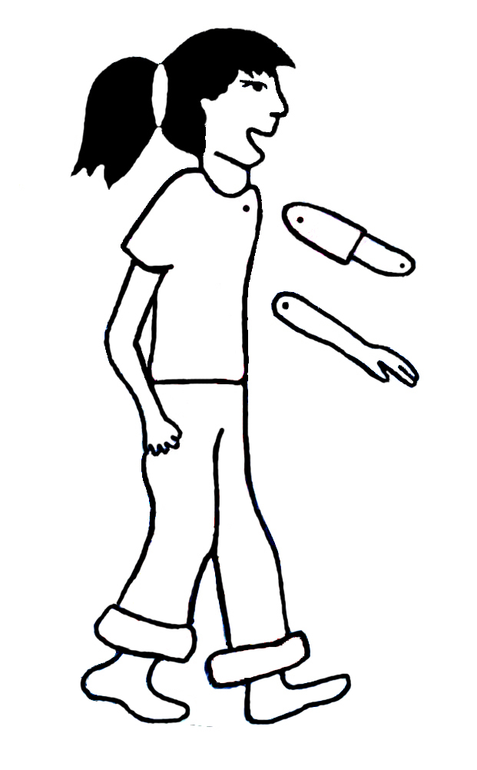
Nur
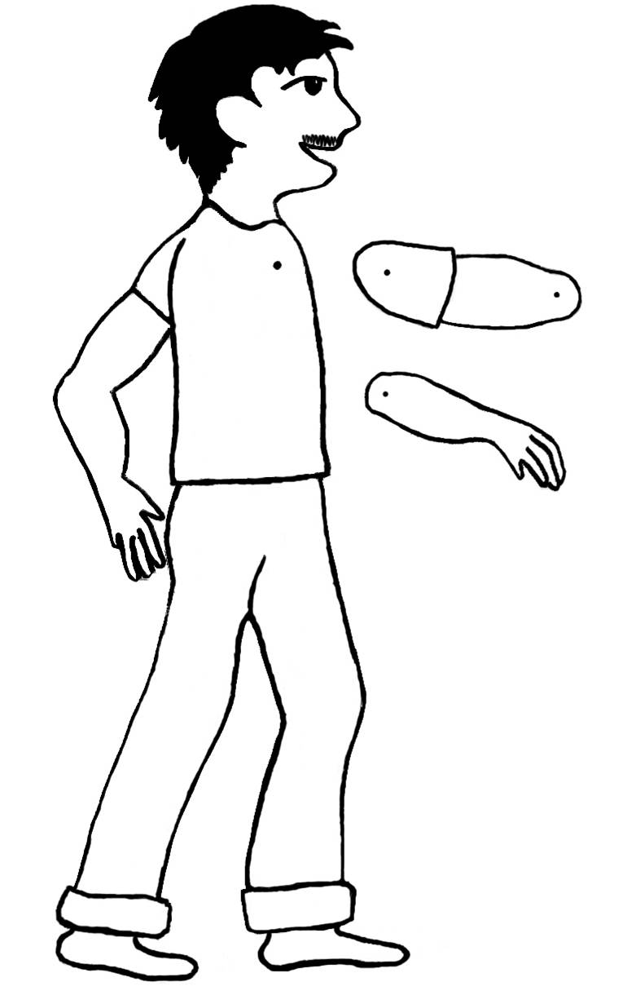

Mr Aziz

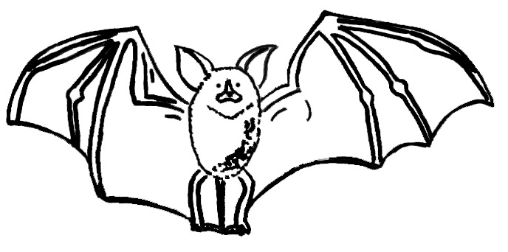
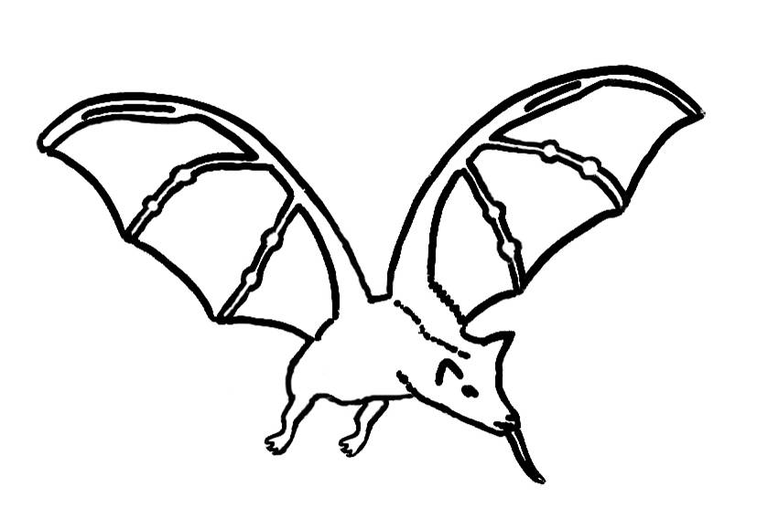
Gema

Polly
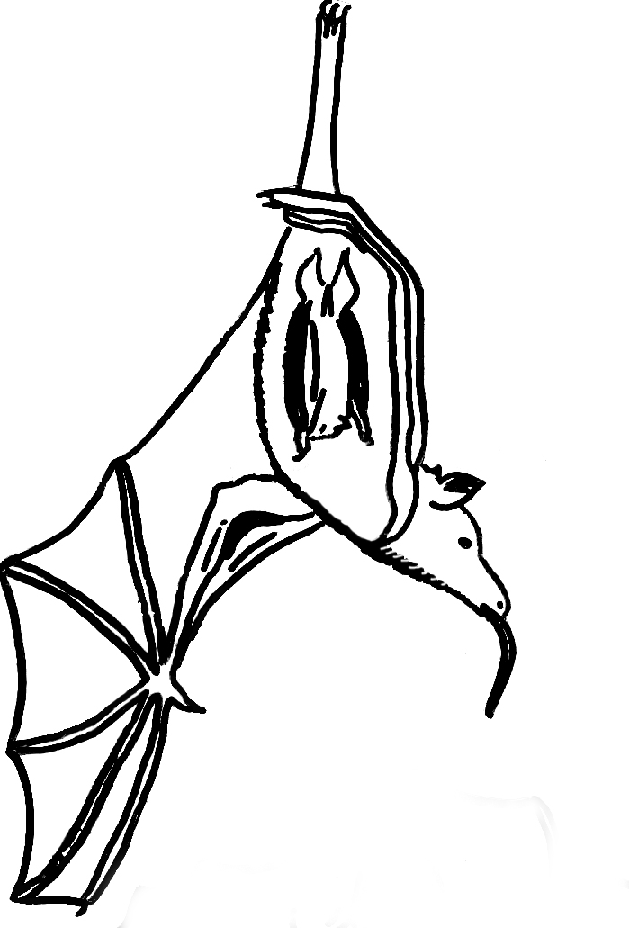
Polly and Baby
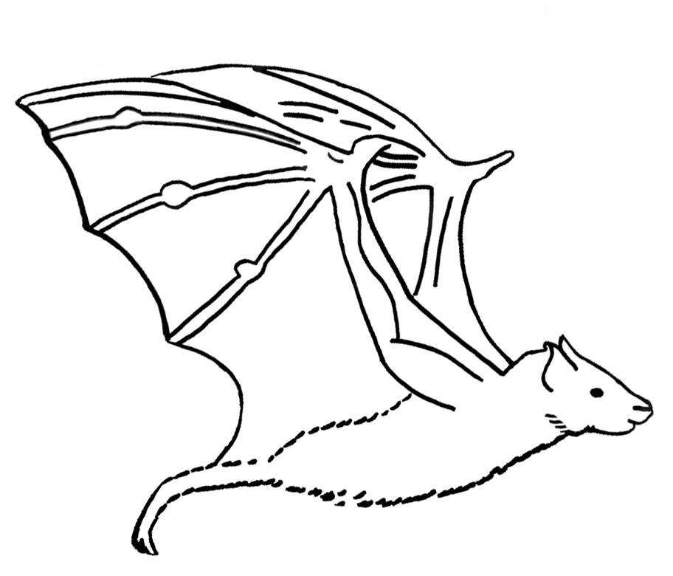

Fruity

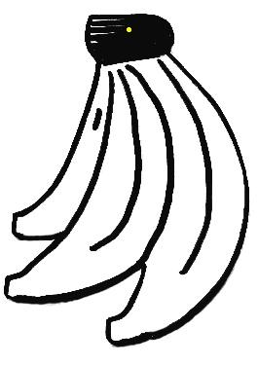
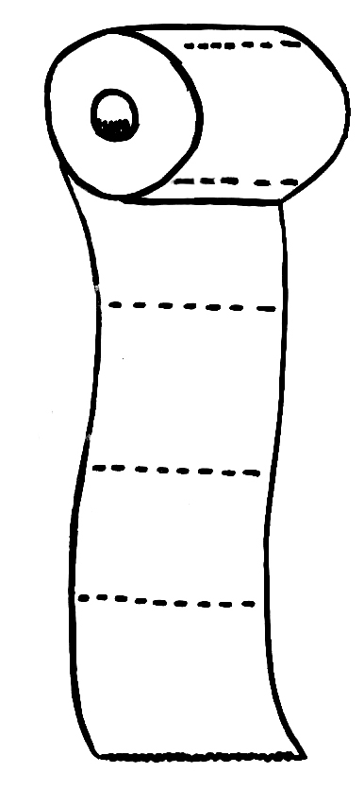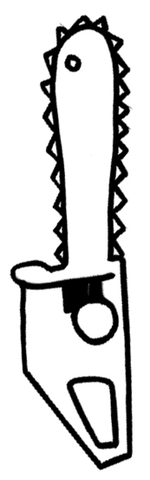
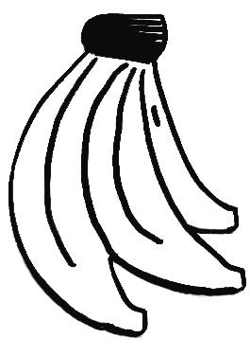

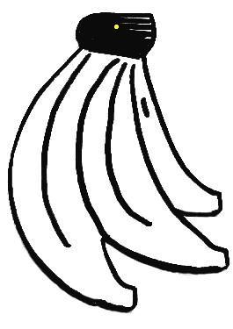 Toilet Roll Chainsaw

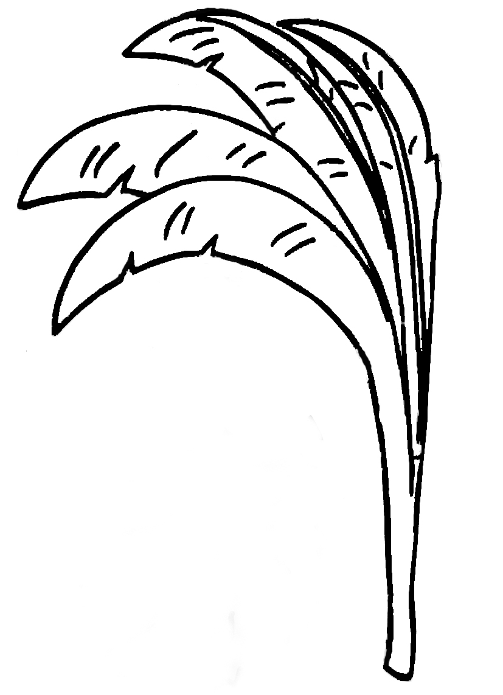
Young Shoot
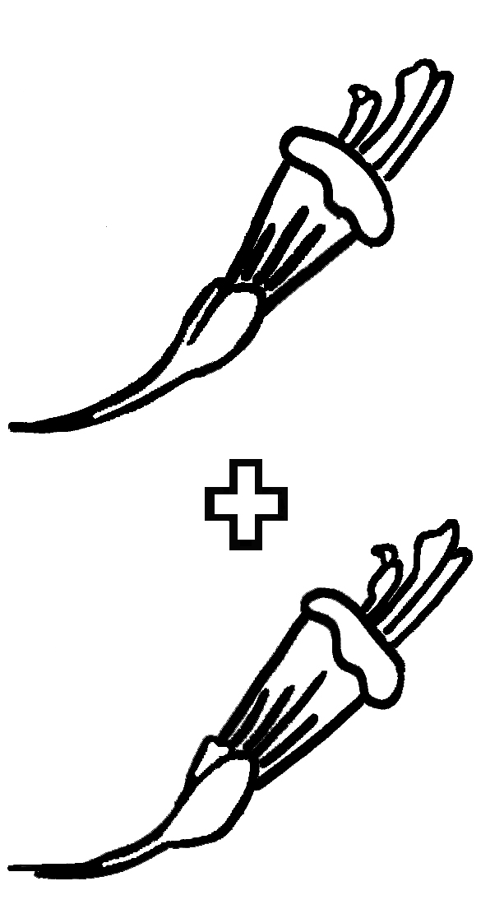
Flashcard

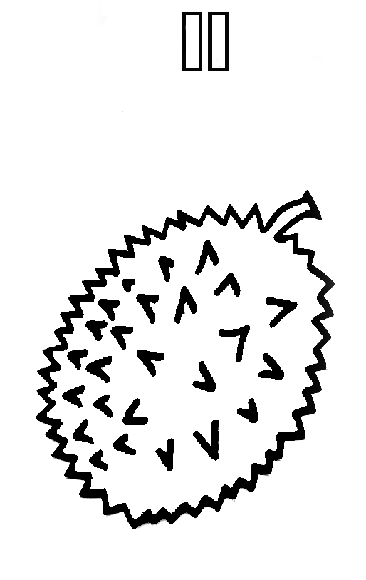
Flashcard
Attach this flashcard to the one before so you get flower + flower = durian
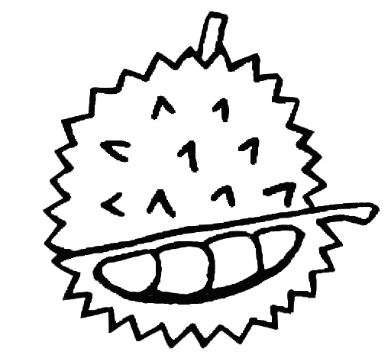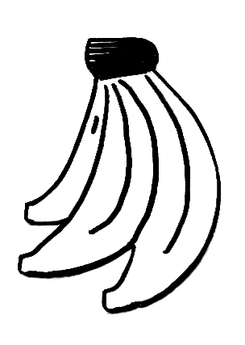

Open Durian Banana

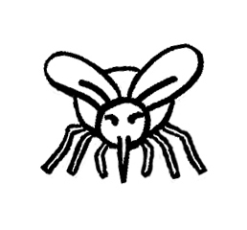
Mosquito
Breaktime: Bat Fruit Salad

Start the break time with a bat fruit salad to demonstrate the importance of bats in our daily lives.

Objectives:
To reinforce an understanding of the importance of bats as pollinators and seed dispersers.

Bat Information for Educators
Fruit bats are vitally important as seed dispersers and pollinators in both forests and crops. They play a major role in forest regeneration by dispersing seeds. Ripe fruit is taken from the parent tree, and the seeds are spread through droppings or spat out.

When megabats eat fruit they prefer to just suck the juices and spit out the seeds and other unwanted parts of the fruit. This leaves more room in their stomachs for the nutritious juices and pulp. The dry remains are called rejecta pellets, and seeds spread in rejecta pellets can germinate and grow into young trees. When the nectar-eating bats drink from flowers, they pollinate them – just like a bee does. When they visit a flower in search of nectar, they are brushed with pollen that they then take on to the next flower, pollinating them.

At least 31 plant species in Malaysia alone rely on bats for pollination. Some of these plant species are important to people too. Altogether, there are nearly 200 economically important fruits in the Old World that are pollinated or dispersed by bats. Trade in durian in South East Asia is worth about $120 million per year (RM 455 million). In Malaysia, sales of petai in the Klang Valley alone amounts to about $2.8 million per year (RM 10.8 million) – all thanks to bats!
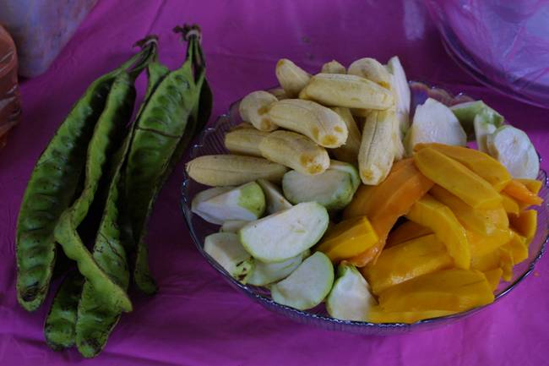
Materials:
Bat pollinated fruit (e.g. banana, jackfruit, mango, papaya, guava, durian and petai)
A large bowl or plate
A knife to cut fruits
Fruit juice
Ice

Instructions:
- Cut up most of the fruit and put them into a bowl, pour mango juice, add some ice and serve.
- Alternatively cut and display the available bat pollinated or dispersed fruits on a plate. Leave at least one of each fruit intact to show the children during the short discussion.

Steps:
- Get the children to queue up for food.
- Have them seated while eating.
- To simulate the feeding pattern of fruit bats, get the children to take a bite of fruit and chew, swallowing only the juice. Then get the children to make the remains as dry as possible and spit out what is left of the fruit.

Game: Bat-Moth

Objectives:
To demonstrate how and why bats use echolocation.

Bat Information for Educators
Like other mammals bats have eyes and can see. But what happens when it is dark and they want to find food? Why don’t they fly into things in their flight path like trees, fences or buildings? How can insect-eating bats find such small, fast-flying prey in the darkness?

Microbats have a complicated hearing system that helps them to hear very well, and has made it possible for them to use sounds that they make themselves to work out where things are. They send out a high-pitched sound and then wait for an echo to bounce back from something. From the returning echo, they can quickly calculate the direction and distance of the object – that is they locate it using echoes and this is called echolocation. If the echoes come from an insect then they are off in hot pursuit to catch their dinner, but if they come from a tree or wall, then it might be time change course. The use of echolocation by the microbats has enabled them to truly exploit the night sky!

Materials:
A group of people to be trees
One or more persons to be bats
One or more persons to be moths
6 blindfolds
Plenty of space

Steps:
- To play, you need a group of people to be trees, one person to be a bat, one to be a moth, a blindfold and plenty of space!
- The bat is blindfolded, and all the rest of the players stand around the bat in a circle about 4 m across.
- The moth joins the blindfolded bat in the circle; and the objective is for the bat to catch the moth. To find the moth, the bat calls out “bat” and immediately the moth must reply with “moth”. This is like a bat shouting out a call and getting an echo back from the moth, and then using that echo to get the direction of the moth.
- Every time the bat calls out, the moth must answer, and both the bat and moth can walk swiftly (don’t run!) around the circle.
- The bat will need to keep calling and to listen carefully for the moth’s replies or “echoes”, until it is close enough to catch and “eat” the moth.
- Got the hang of it? Now have several bats and several moths at once.
- Now add in some trees – trees stand still and call out “tree” every time the bat calls “bat”. Any bat that bumps into a tree is out of the game!
- Everyone should take a turn at being the bat and moth.

Discussion Points for Educators
- What happened when a bat started to close in on a moth?
As real bats get nearer to their prey they start calling more and more often and the calls get shorter as they try to get as much information about the location of the insect as possible. During the final attack the bat will be producing up to 200 calls per second!
- Did the moths actively avoid the bats or did they just fly around the enclosed area?
You probably found that your moths did all they could to avoid the bats – because they could both hear and see them. In the wild, moths can’t see the bat coming, but some have developed a simple hearing system that is tuned to the frequencies that many of the bats use. When they hear a bat coming they change course to avoid it. If the bat is too close they take emergency action and stop flying immediately – they plummet and spiral downwards out of harms way!
- Was it easier to find an insect when it was out in the open, away from the trees, or when it was near the trees?
Many bats find it difficult tell insect echoes from tree echoes when the insects are very close to the trees. To get around this problem, bats that hunt in dense vegetation often rely on their ability to pick out the fluttering of insect wings.

Game: Where’s My Baby?

Objectives:
To demonstrate how mother bats find their young in large maternity roosts.

Bat Information for Educators
When it is time to give birth, the females of many bat species gather together in a maternity roost. The baby bats, called pups cling to their mothers and suckle milk from the nipple under her arm.

When the pup is very young, the mother may carry it with her when she is foraging. But after about 10 days the pups are too big for that, and have to be left behind when the mother goes to look for food. When she returns she finds her baby by recognising its voice and smell. She can manage this even if there are hundreds of pups to choose from, in fact as the pups cluster together for warmth, there may be up to 5000 of them in a square meter.

Materials (Based on Mother-Pup Pairs):
Cotton wool balls
4 different scents (e.g. vinegar, cinnamon, garlic, vanilla, perfume)
4 blindfolds
4 pairs of people (one as the mother and the other as the baby)
Other people (as many as possible)
Lots of space

Steps:
- All the children are bats in a maternity colony – most of them are pups, but you need to select 4 mothers, and their 4 pups, so that you have 4 mother-pup pairs.
- Each of the four selected pups is given a cotton wool ball with a scent (e.g. vinegar, cinnamon, garlic, vanilla, perfume).
- The mother gets to know the scent of her pup. The baby is also assigned a voice (make up tongue clicking patterns), and the mother and pup need to practice a few times to be sure that the mother can recognize her baby’s scent and sound. The mothers are then blindfolded.
- All the other pups, and the 4 whose mothers will be looking for them, are now arranged in the ‘roost’.
- All the babies start clicking at with their own pattern.
- The blindfolded mothers must now try and find their own pups, based on the click patterns.
- If a mother bumps into a designated ‘baby’ the baby is required to place the cotton ball near the nose of the mother.
- The winner is the mother and baby who find each other first!

Discussion Points for Educators
- How did the mothers first get near to their pups?
Did the mothers randomly sniff all the pups or wait until they found one making the right clicking pattern? Sound should be a better way to find the pups at first because it works over longer distances than smell can. In fact in the wild the mother has a vague idea of roughly where she left her pup and goes to that part of the roost first. Then she calls to and listens for her pup. Finally, she smells it to be sure it is definitely her youngster.
- Why do you think it is so important for the mother to find the right pup?
Baby bats are always hungry and it is a very demanding time for the mothers trying to get enough food to make milk for the young and to keep their own strength up. The hungry pups are always on the look out for a free meal and will try and feed from any female that comes near. So its’ up to the mother to make sure she is only feeding her own pup – otherwise she is wasting all her energy and milk on someone else’s pup and her own could starve.
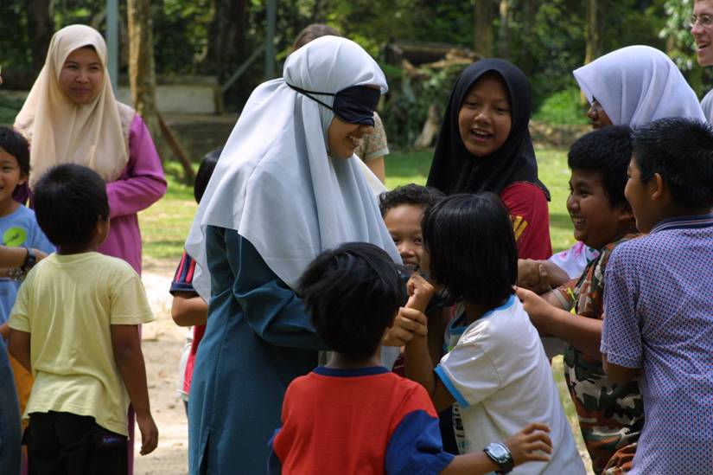

Quiz

A quiz is a fun and exciting way for children to show you what they have learned. It is a good idea to tell the children at the beginning of the party that there will be a quiz so they are motivated to remember what they have found out.

Objectives:
To demonstrate and reinforce what the children have learnt.

Materials:
A score board (something to clip this up with so it is visible)
Pen
One person to read the questions
One person to keep score and check who has answered correctly

Instructions:
- Print out the quiz cards onto coloured cardboard.
- Cut out the questions.
- Ensure each card has its individual questions and corresponding answers.

Steps:
This is one way to conduct the quiz, however it is not the only way. Use your imagination to make other alternatives.
- Tell the children to sit in their groups.
- Explain the rules of the game.
- Read the questions clearly.
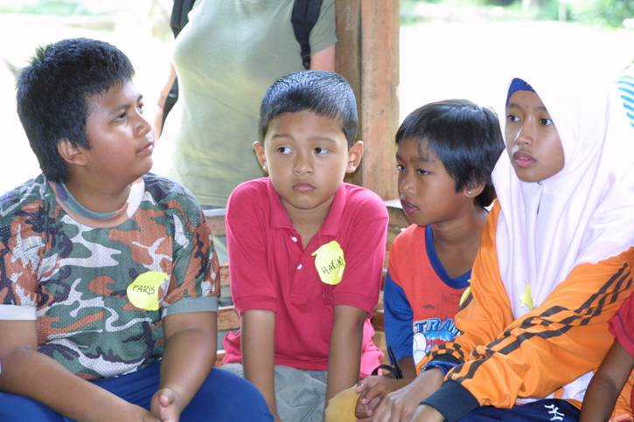
- To answer they must call out the name of their group before the other groups.
- They can only answer after the question has been read out and they have shouted their group name once.
- The group with the most correct answers wins.
Quiz Questions

Do bats fly in the day or at night?  Night | How many species of bats are there in Malaysia?  125 species
What do insectivorous bats eat?  - Fruits  - Insects  - Nectar | How many fingers do bats have?  5 fingers, just like us
Name the ways that bats help humans.  Seed dispersal,  Pollination,  Pest control,  Disease control | Name two places where bats sleep/rest.  Tree branches,  Tree hollows,  Caves,  Buildings/houses  Under leaves

Bats are flying mice! True or false?  False | What kind of animals are bats?  - reptiles  - mammals  - amphibians
How many mosquitoes can a bat eat in an hour?  600 | Name a plant that depends on bats for seed dispersal/pollination?  Durian, petai, rambutan, mangoes,bananas, papaya, jackfruit
Bats are blind! True or false?  False | What do nectarivorous bats do?  - eat flowers  - destroy plants  - pollinate flowers

How do insectivorous bats find their food at night?  Echolocation/sonar/  ultra sound | All bats eat insects. True or false?  False
How do mother bats find their babies when the nursery is so large?  Smell or  voice recognition | How many babies does a mother bat give birth to in a year?  - 1  - 5  - 50
Bats use their __________ to produce sounds when they catch insects.  Mouth and nose | 18. The largest bat in the world can be found in:  - America  - England  - Malaysia

Grand Finale

It is important that the end of the party is as exciting as the beginning for this is what the children will remember most. It is another chance to see if the children’s knowledge or attitudes have changed. Presenting them with a gift at the end of the party will help remind them of their fun bat experience.

Objectives:
To reinforce the message that bats are interesting, pleasant and important animals.
To find out what the children have learned and if their attitudes towards bats have changed.
To give the children quiz prizes and bat memorabilia gifts when ending the bat party.

Materials:
Bat Attitude Survey questions
Comic (one per child)
Bat mobile (one per child)

Steps:
- Ask Bat Attitude Survey questions.
- Summarise what they’ve learned.
- Congratulate them all and present the winning group with prizes.
- Present the Bat Mobile.
- Thank everyone.
Bat Attitude Survey Questions
Questions may be asked and recorded on a sheet of paper such as:
    - Do you like bats?
    - Are bats clean?
    - Are you afraid of them?
    - Are bats useful animals?
    - What are bats most like – birds, mice, shrews?
    - How many different kind of bats do you think there are in Malaysia? – 5, 20, 50, 100, more than 100?

Game: Memory Bat

Materials:
2 Copies of each picture (16 pairs)

Instructions:
Activity Preparation
Bat pictures
Cardboard
Glue
Scissors

- Cut out the templates from page 96-99 using a pair of scissors.
- Make the templates into individual cards by gluing the pictures onto cardboard.

Steps:
- Arrange the cards facing downwards in random order.
- Each person is allowed to reveal only two pictures at a time. If he gets it right, he may continue to reveal the next pair. If he does not get a pair, it is the other person’s turn to play.
- The winner is the person who reveals the most pairs.

Memory Bat Template
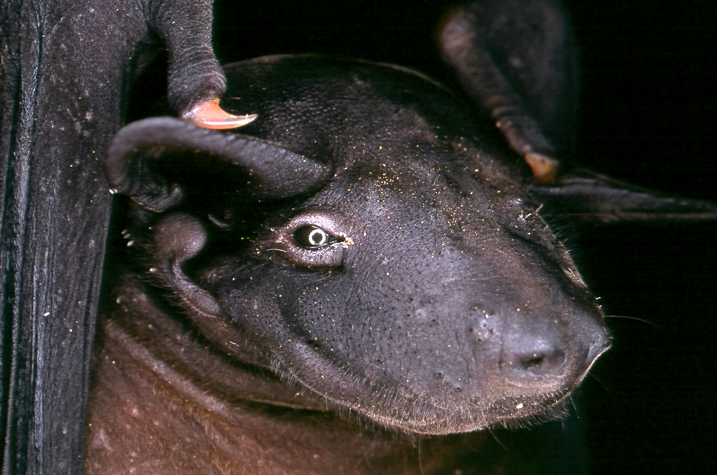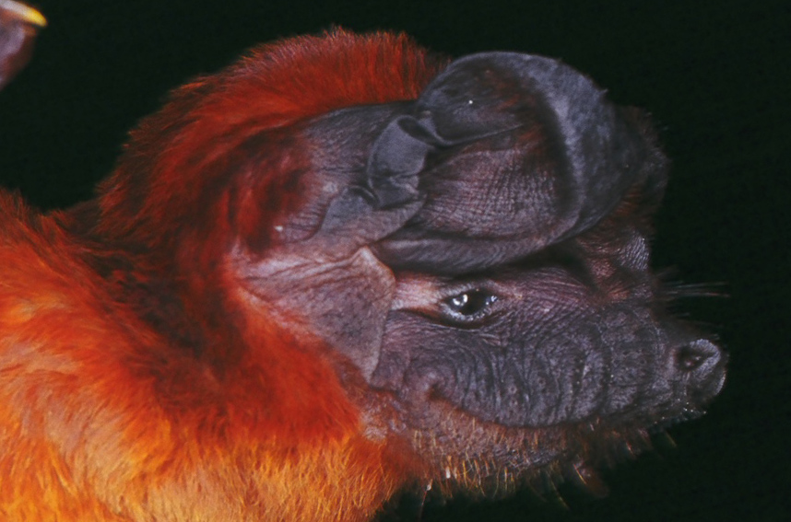
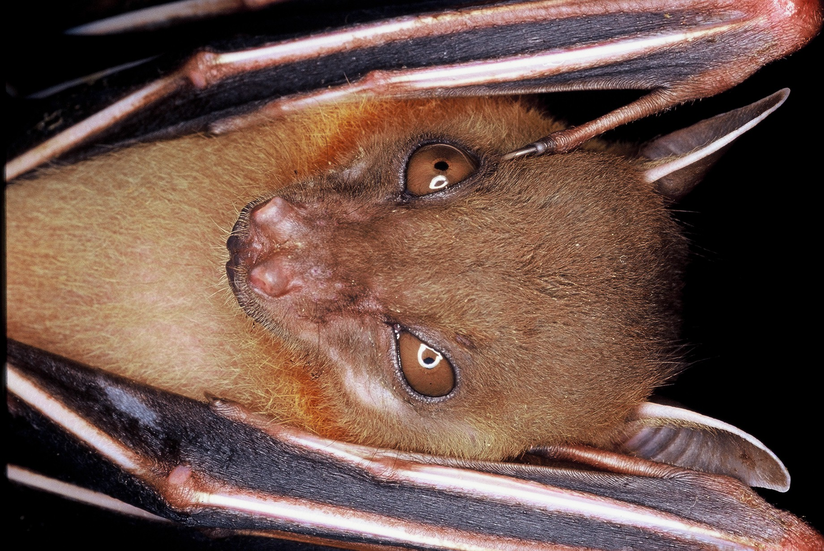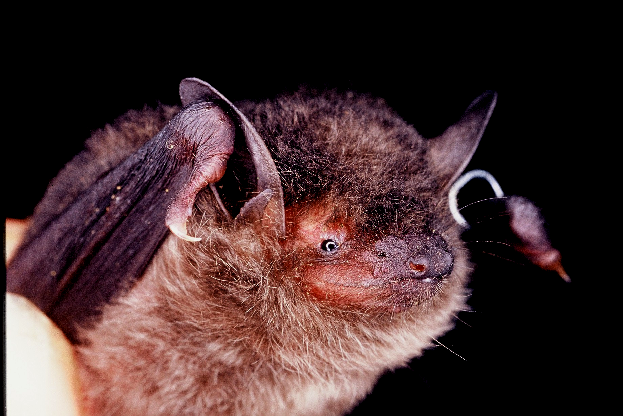
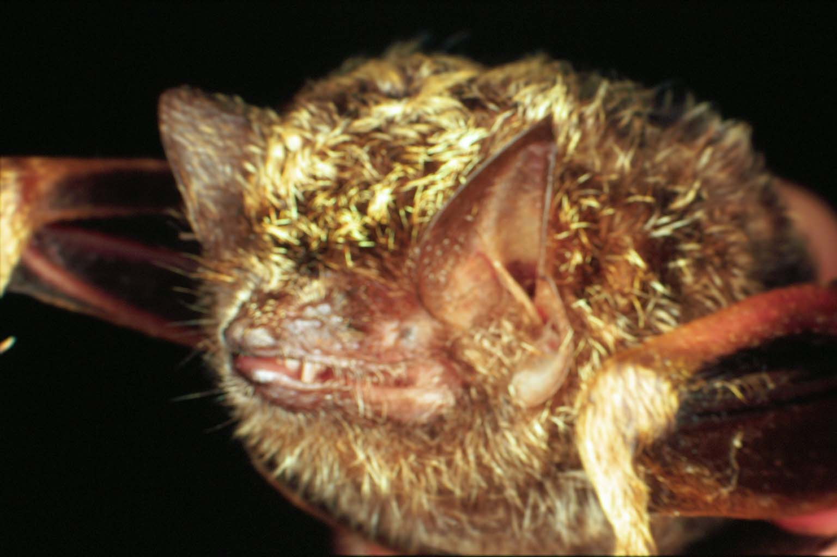
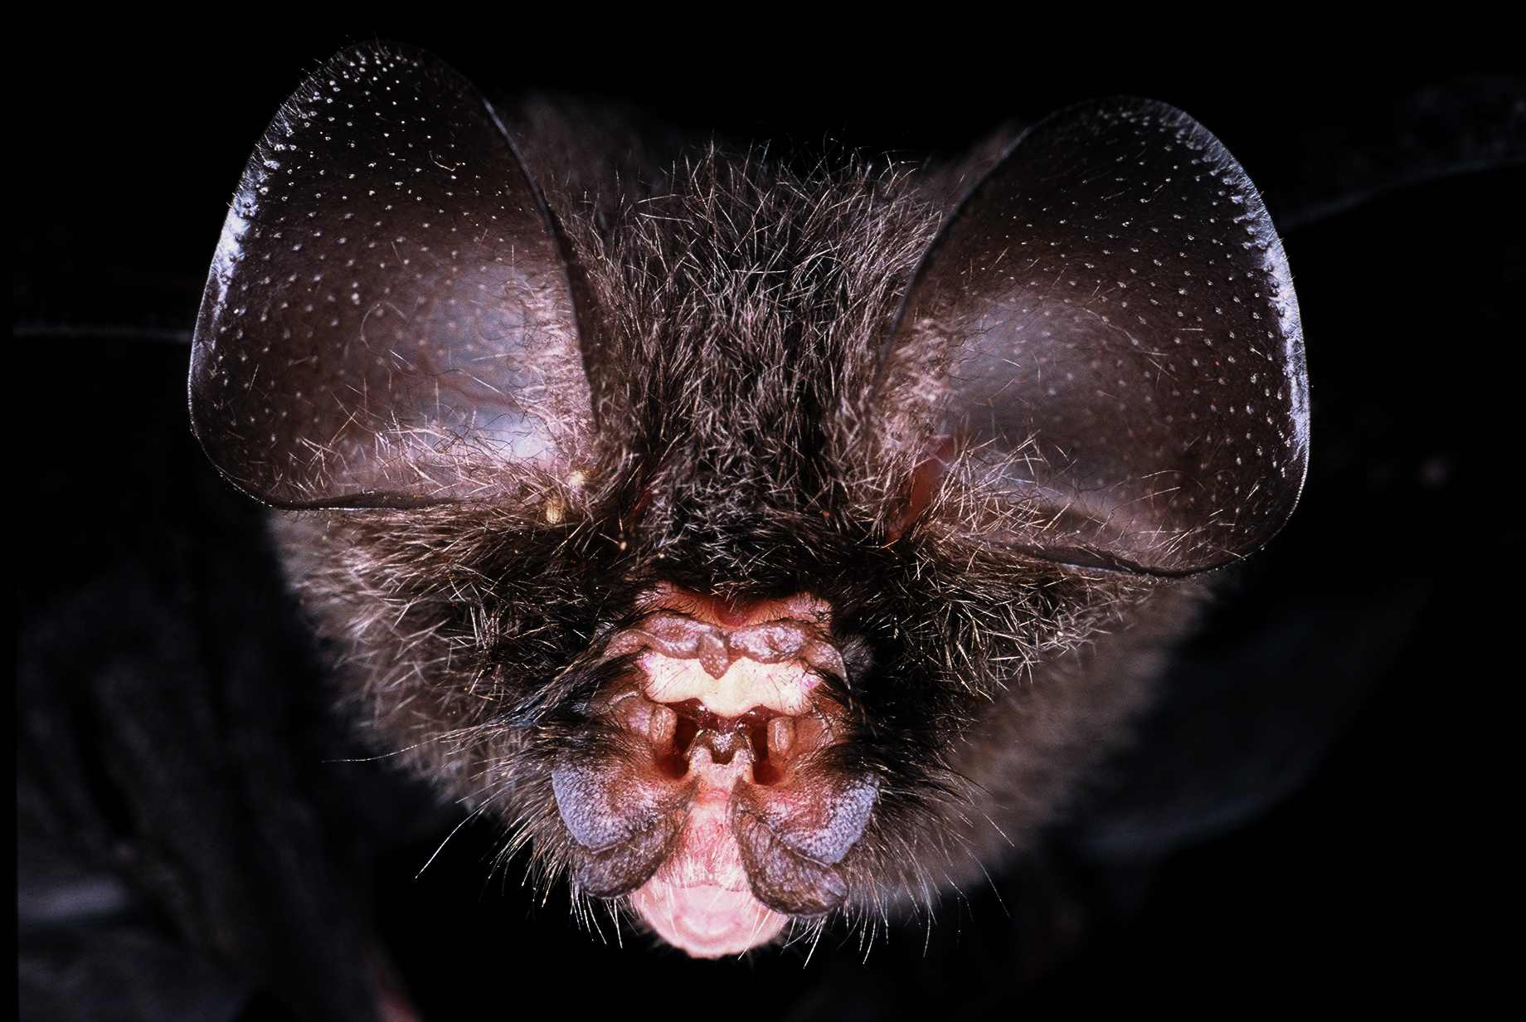
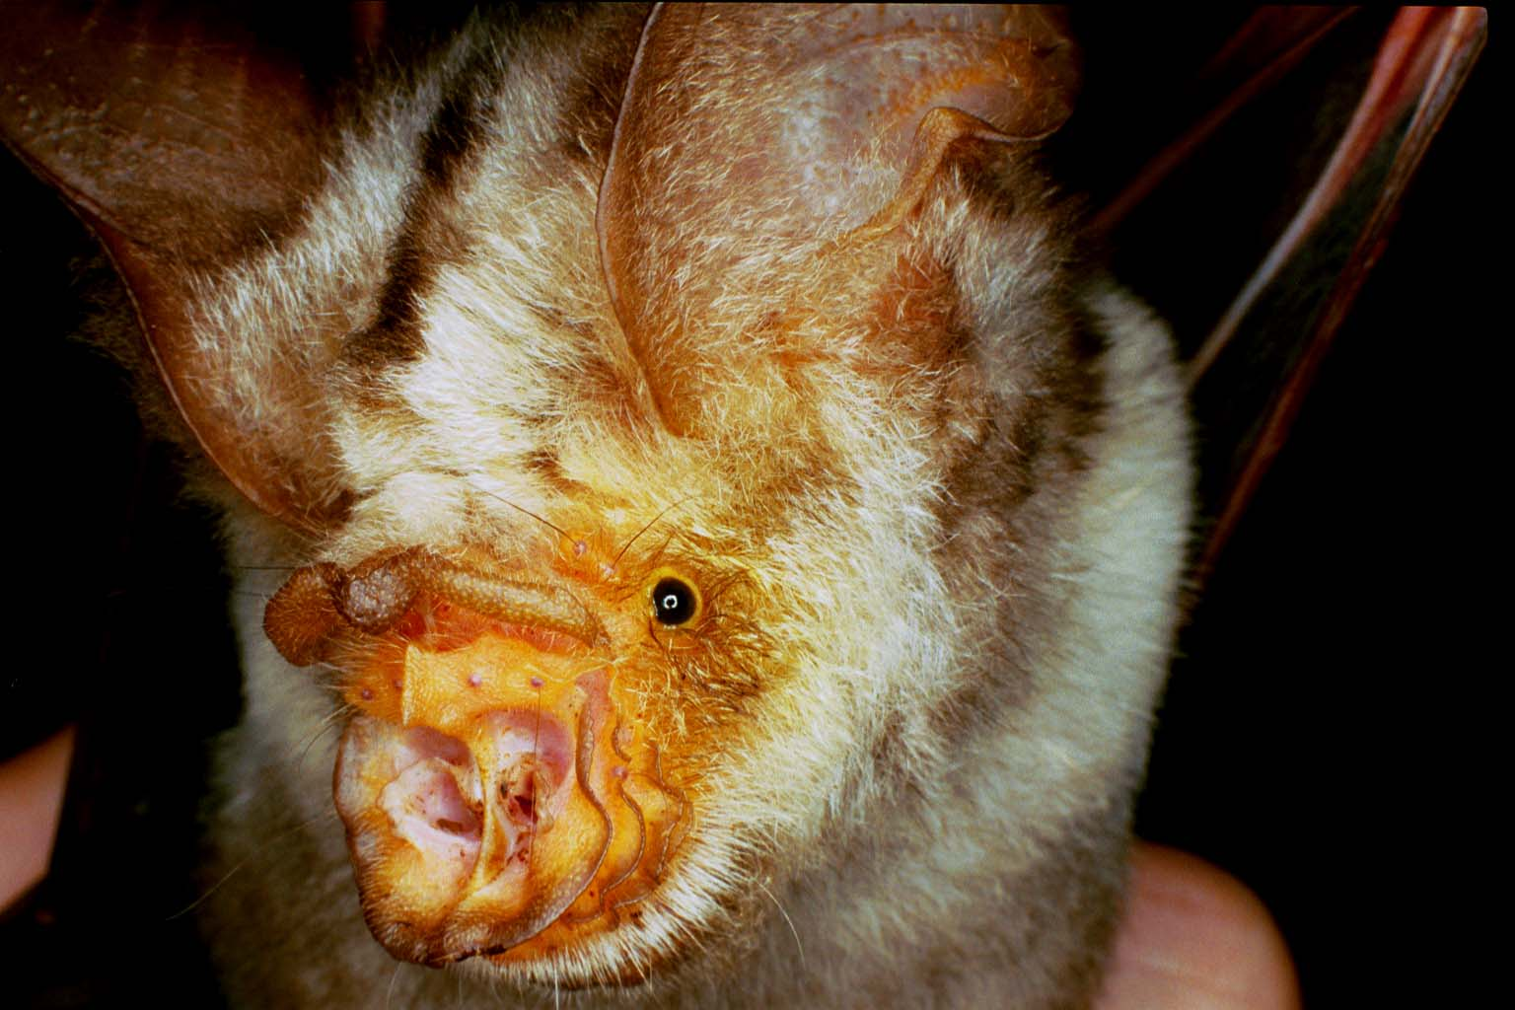
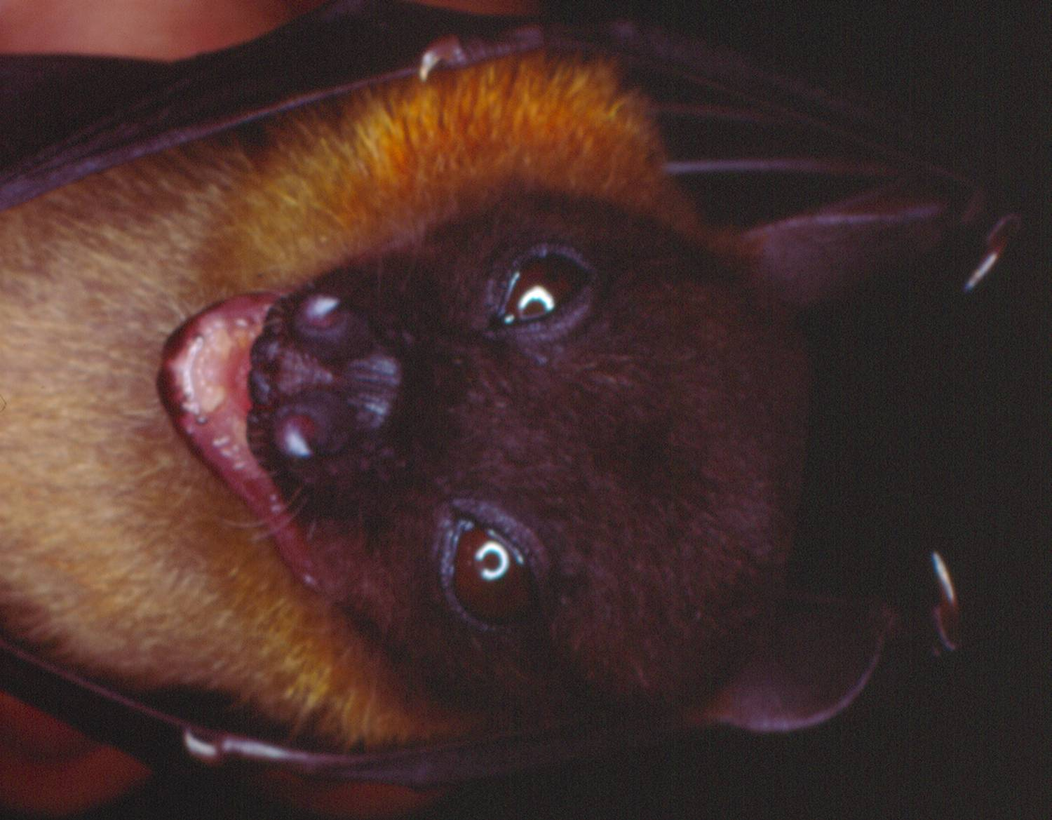
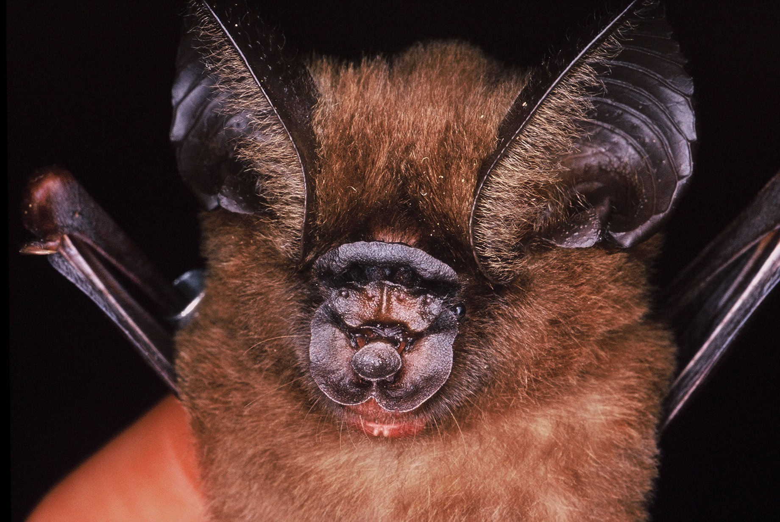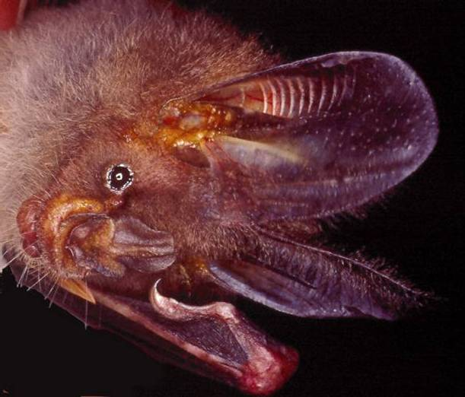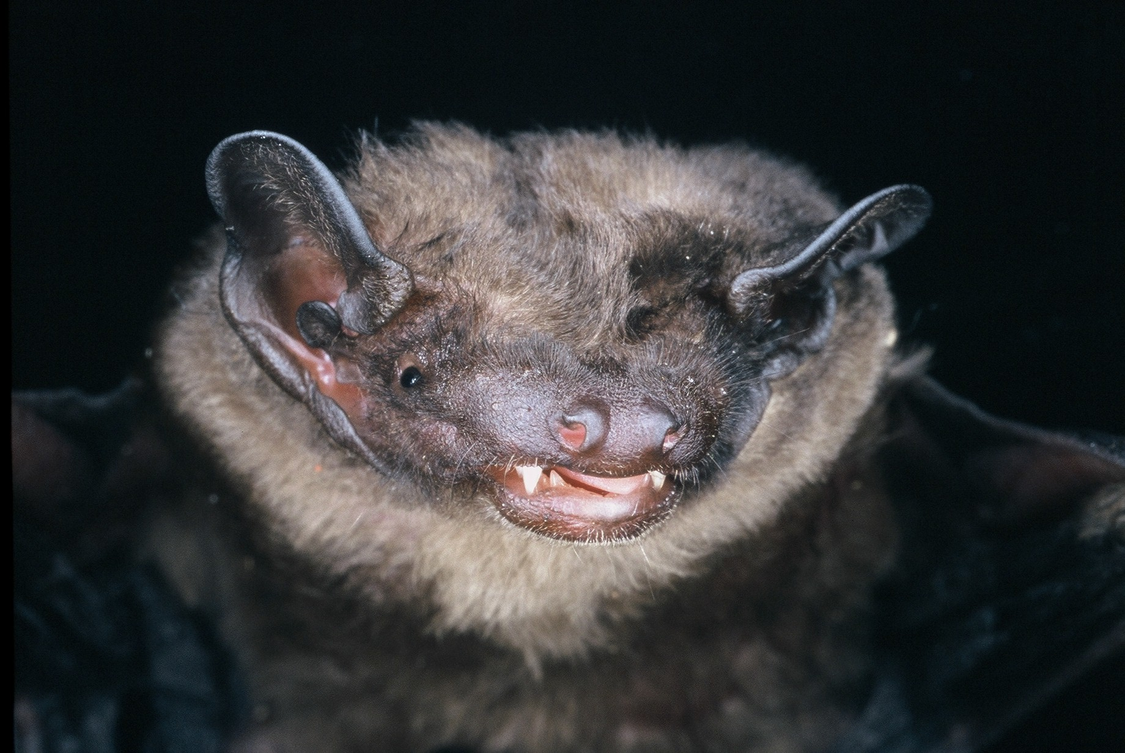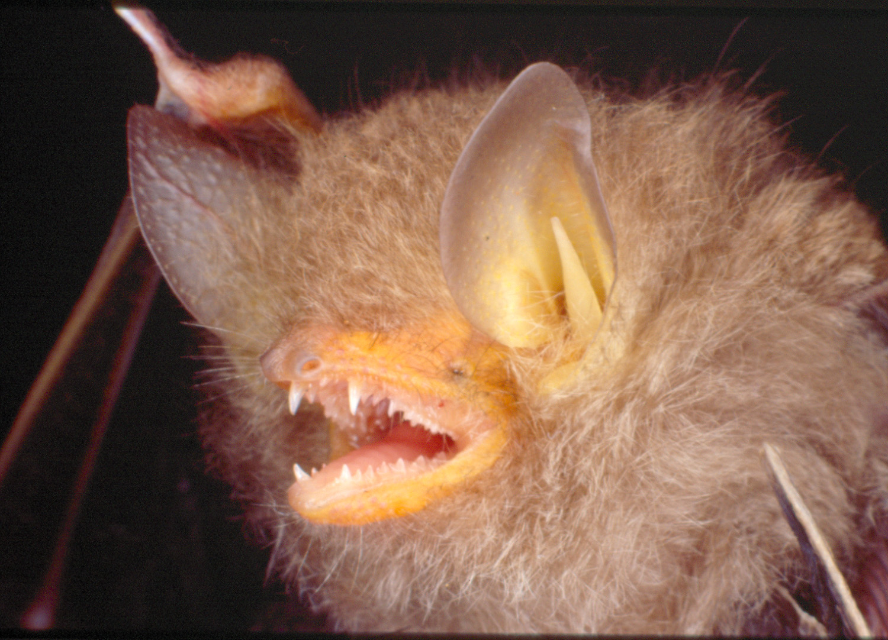
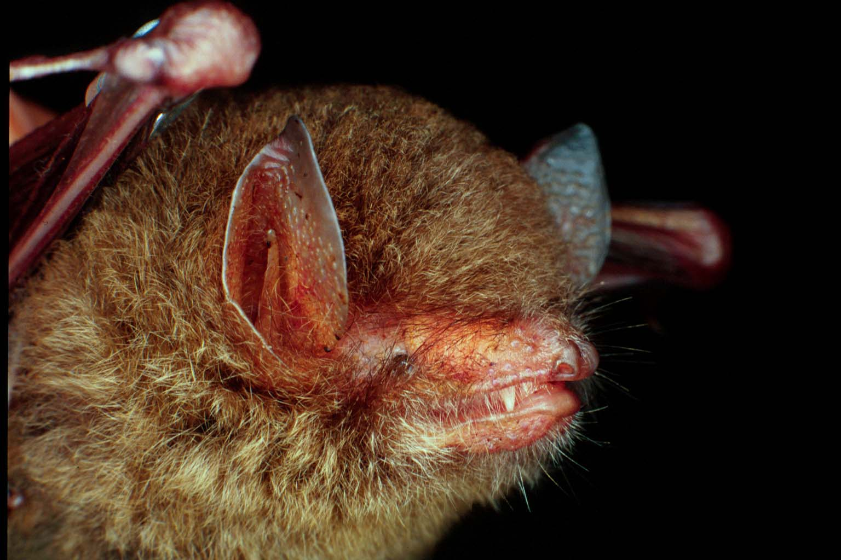
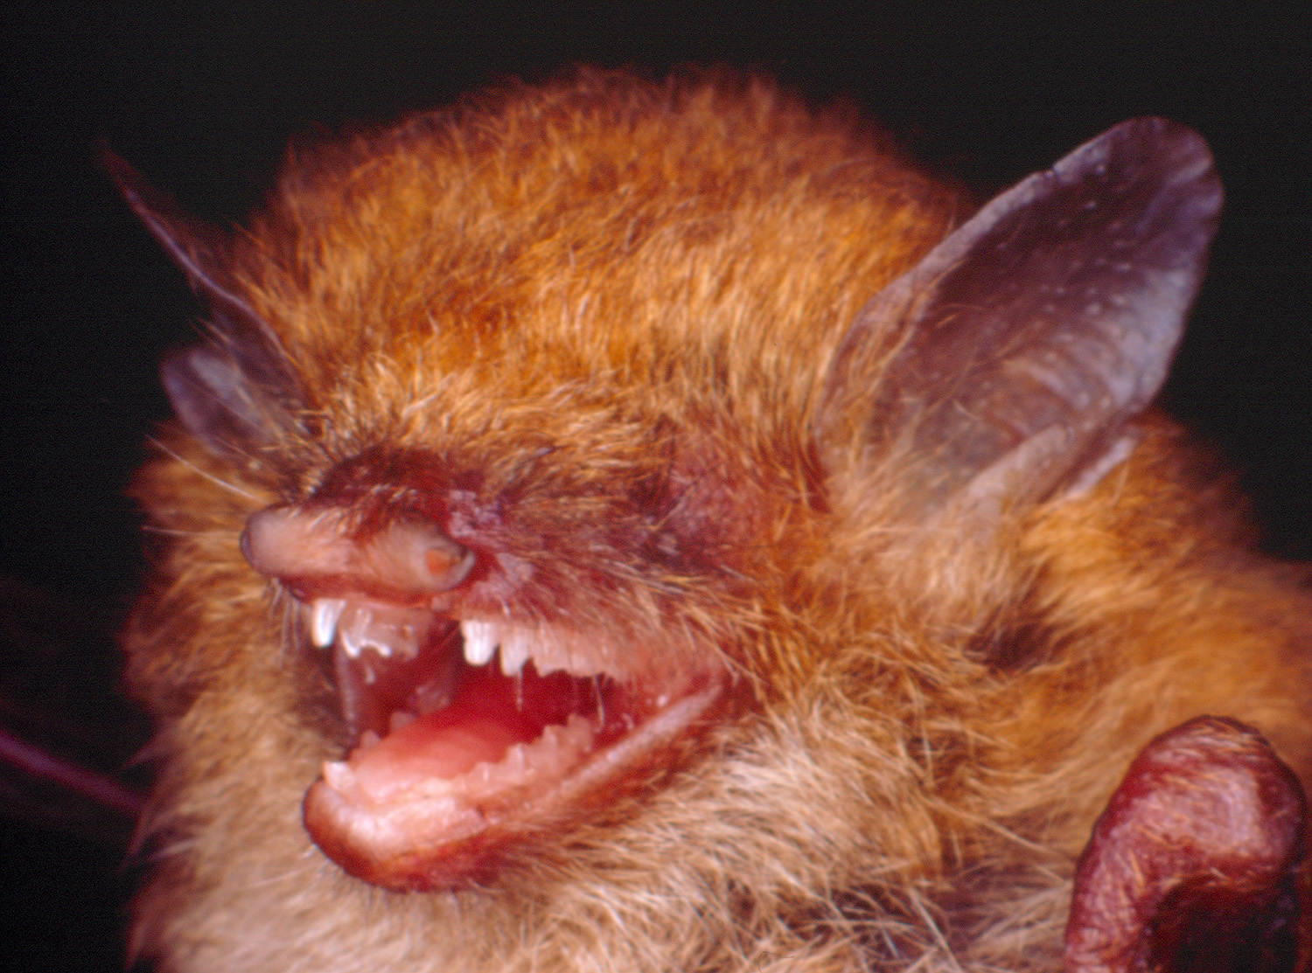
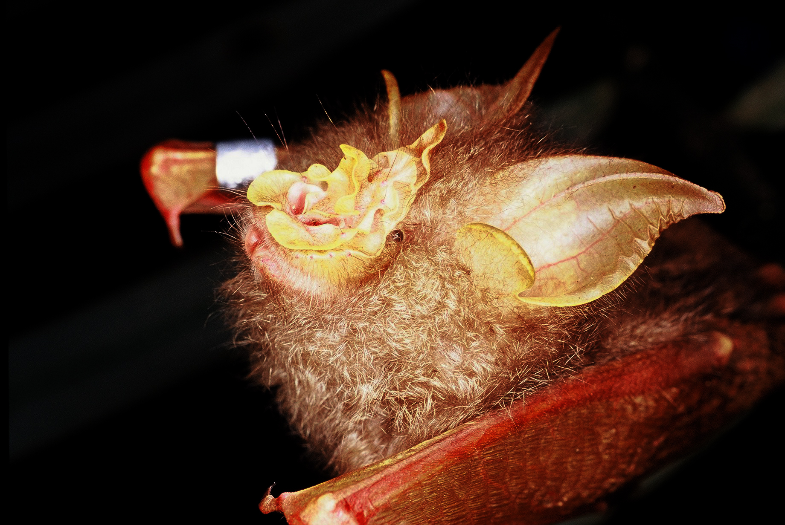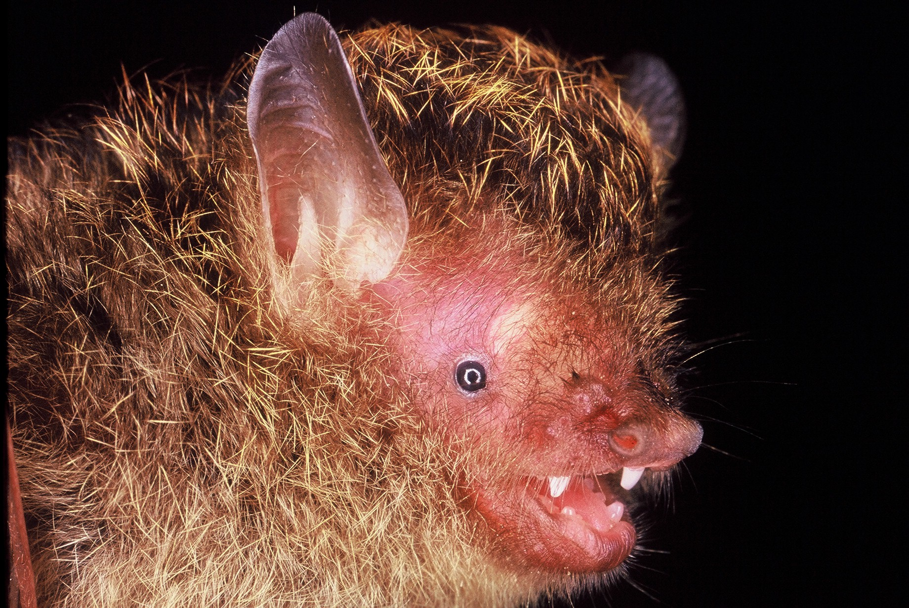

Bat Mobile

A way of reinforcing the message given in the puppet show is to give children a bat mobile, which can be hung in their rooms. This will help them to remember the different kind of bats that were seen in the puppet show and remind them of the role of bats in society.

Objectives:
To reinforce the message in the puppet show.

Materials:
Bat templates
A chopstick or long twig (20cm or more)
Thread
Ruler
Scissors
Colour pencils or pens

Instructions:
Activity Preparation
Bat templates
Cardboard
Glue
Scissors
Thread
Needle
Chopstick or long twig

  - Cut out the templates from page 102-107 using a pair of scissors.
  - Glue the templates with its corresponding image onto either side of a piece of cardboard.
  - Cut the cardboard into the shape of the bat template.
  - Punch a hole with a needle where indicated on the template.
  - Take the chopstick and using a pair of scissors, mark three grooves in the stick; two at each end about 1cm from each end and one in the middle.
  - Cut 3 lengths of thread; 30cm, 50cm and 30cm.
  - Cut 1 length of thread measuring 50cm for suspending the mobile.

Steps:
- While sitting in their respective groups, give the children the templates for making the mobile. (Note: This activity requires adult supervision).
- Ask the children to colour in the mobiles.
- Glue the mobile templates onto a piece of cardboard and cut out accordingly.
- Help the children tie the end of each line into the three grooves, making sure the longest one is in the middle.
- Attach the mosquito to the middle of the first 30cm nylon fishing line by making a knot. This is followed by tying the insectivorous bat at the end of the first 30cm nylon fishing line.
- Attach the bananas to the middle of the 50cm nylon fishing line by making a knot. This is followed by tying the frugivorous bat at the end of the 50cm nylon fishing line.
- Attach the flower to the middle of the 30cm nylon fishing line by making a knot. This is followed by tying the nectarivorous bat at the end of the final 30cm nylon fishing line.
- Finally, attach the last 50cm string to the two ends of the chopsticks to suspend the mobile.

Bat Mobile Templates

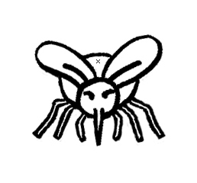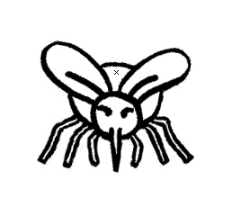
Mosquito

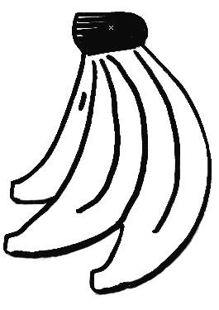

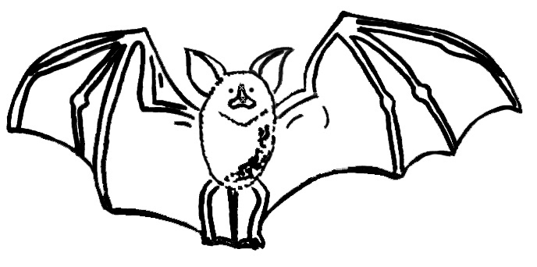
Gema
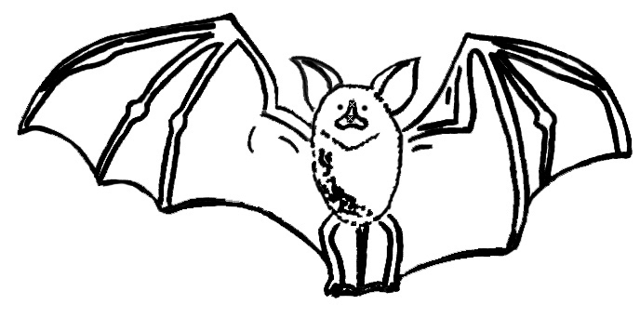

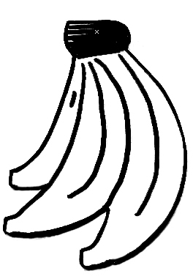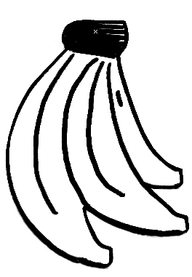

Banana

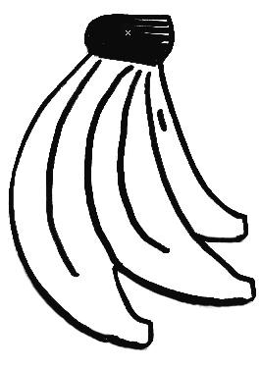
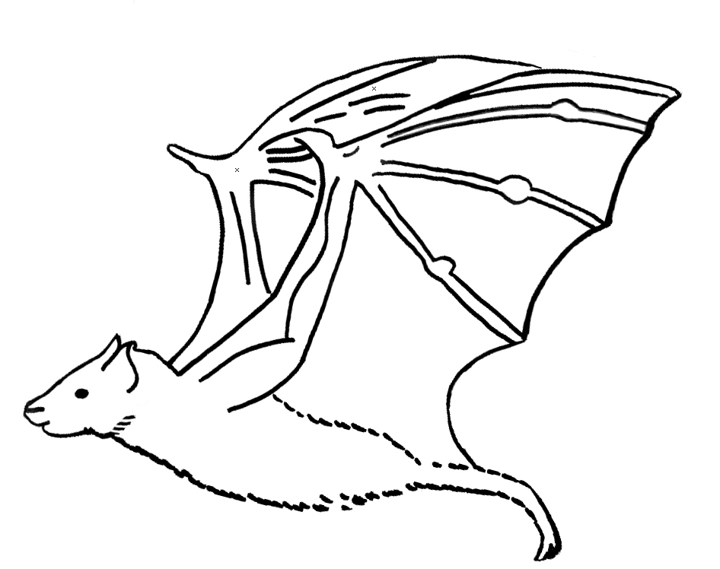
Fruity
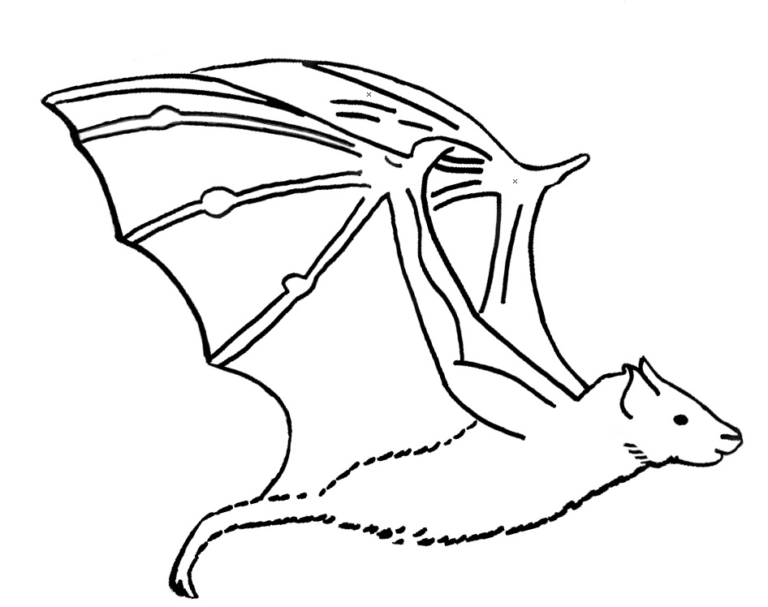

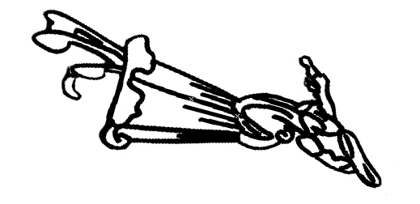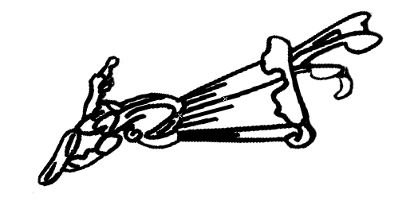
Flower

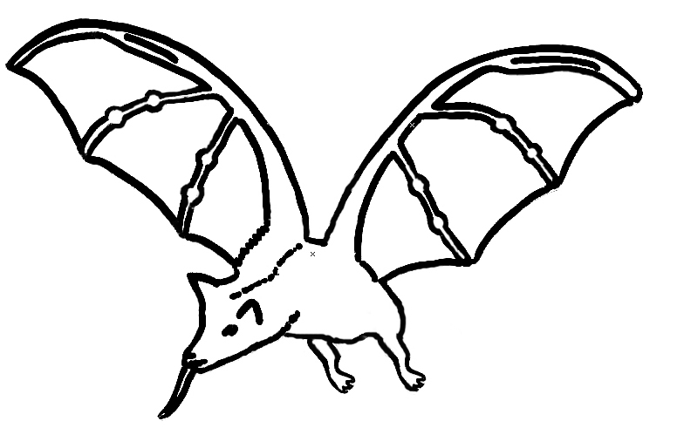

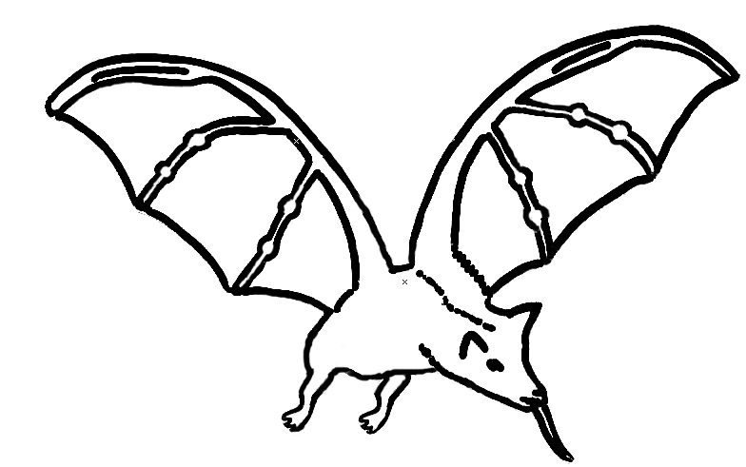

Polly



